**Text for report**

At the September 2017 Council meeting, Dr. Jameal Samhouri (NWFSC) briefed the SSCES on a framework for setting reference levels for the indicators reported in the CCIEA report to the Council. The framework, which has been published in the journal Ecosphere (Samhouri et al., 2017), aims to find which pressure variables (environmental or anthropogenic) are related to a set of selected state variables (generally indices of ecological integrity) and to assess whether the relationships between the pressure and state variables are non-linear, i.e. there is a significant change in the relationship at some threshold value for the pressure variable. The SSCES considered the General Additive Model (GAM) approach for defining non-linear relationships between pressure and state variables appropriate, as well as the method we used to identify threshold values and their uncertainty.

We identified three thresholds with well-established hypotheses for the relationship between the pressure variables and state variables in the September presentation. These included threshold responses of California sea lion pup production to the PDO and NOI, as well as the summer anomaly of the Northern copepod index in relation to the winter mode of the NPGO. This initial threshold identification analysis relied on data from 1996-2014. Based on the presentation, the SSCES recommended that the ecosystem report for the March 2018 Council meeting include a small set of results for pressure variables where a threshold is indicated–with the basis for the threshold included in background material.

Based on this feedback, we re-ran the analysis presented in September using data updated through 2016, focusing on pressure-state variable combinations with well-established hypotheses to connect them. The only change to the analysis made for this report was to consider relationships nonlinear if the effective degrees of freedom (EDF) equaled or exceeded 1.8 (our previous cutoff was EDF >= 2.0). From this new analysis, we can make four general conclusions:

1. Most pressure-state relationships we examined were linear. Importantly, despite no evidence of a threshold, some of these linear relationships are potentially important reflections of links between oceanographic changes and secondary productivity in the California Current (Fig. A1).
2. One pressure-state relationship identified as nonlinear in the September presentation remained nonlinear with the addition of two more years of data. This result emerged for the threshold response of California sea lion pup production to the summer mode of the NOI (Fig A2). The NOIs captures the quick transition between El Nino and La Nina conditions experienced in the North Pacific, and highly positive values were likely indicative of La Nina conditions in subsequent years. Thus, future analyses should consider lag-one NOIs in relation to state variables.
3. The addition of two years of data caused one pressure-state relationship previously identified as nonlinear to become explained most parsimoniously as linear. This relationship was that between the summer anomaly of the Northern copepod index in relation to the winter mode of the NPGO (Fig A3). Increasingly positive values of the NPGO in winter are associated with greater upwelling strength, nutrient transport into the photic zone, and primary productivity (Di Lorenzo et al. 2008), which could fuel the increased secondary productivity we observed. However, the anomalously low value for the summer Northern copepod index in 2016 (matched only by that observed in 1998) reduced statistical support for a nonlinear relationship.
4. Several pressure-state relationships that were identified as linear in the September presentation are best supported by a nonlinear model after the addition of two more years of data (Fig A4). These include threshold responses of the summer and winter anomaly of the Northern copepod index in relation to the summer mode of NOI, and California sea lion pup growth and the summer modes of NOI and PDO.
5. In addition to these nonlinear relationships and threshold values identified with well-established hypotheses, we also found two significant nonlinear relationships with threshold values that require follow-up discussions with the individual component experts to discern the specific underlying mechanistic link. These include threshold relationships between groundfish mean trophic level and the summer mode of PDO and groundfish species density and total fisheries landings.

In summary, this updated analysis suggests that some thresholds are robust to the addition of new data, even under recent, potentially abnormal oceanographic conditions, while other thresholds are not, and that additional data will in some cases provide the statistical power necessary to establish a nonlinear pressure-state relationship. Future research will examine potential mismatches in the spatial and temporal scale of data for both pressure and response variables and we will focus new efforts in 2018 & 2019, including an IEA-funded workshop, on nonlinear and threshold relationships between Puget Sound and Central Valley salmon stocks and known environmental and anthropogenic pressures.

**Figures for report**

Fig A1. Relationship between the winter copepod anomaly and PDO summer (Jul-Sep). The dashed line is the GAM smoother, gray polygon is 95% CI, points are raw data.

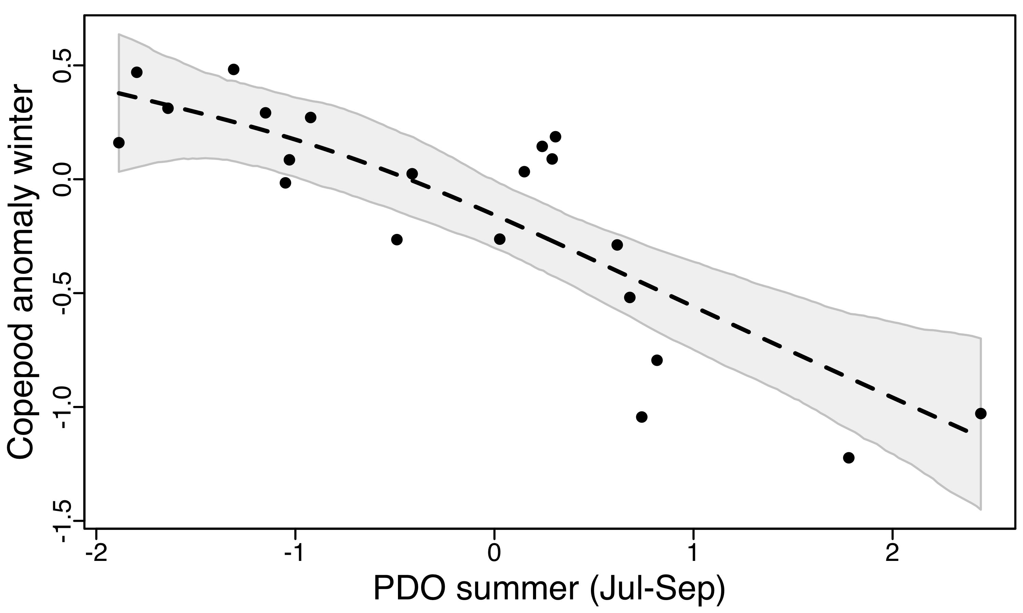

Fig A2. Relationship between California sea lion pup production and the summer mode of the NOI (upper panel). The dashed line is the GAM smoother, gray polygon is 95% CI, points are raw data, thick solid line indicates the threshold range where the 95% CI of the second derivative (lower panel) does not include 0, and red dotted arrow indicates the best estimate of the location of the threshold (i.e., where the second derivative is most different from zero within the threshold range).

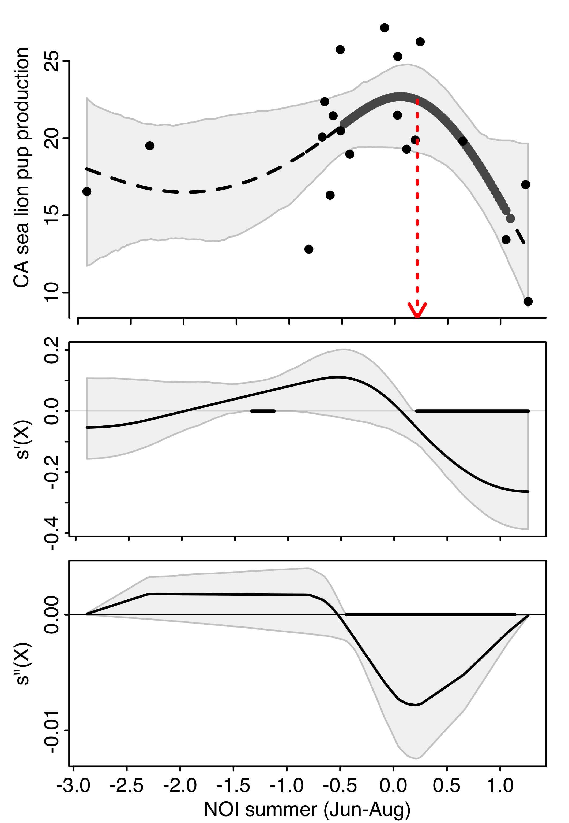

Fig A3. Relationship between the summer anomaly of the Northern copepod index in relation to the winter mode of the NPGO. See Fig A1 caption for additional details.

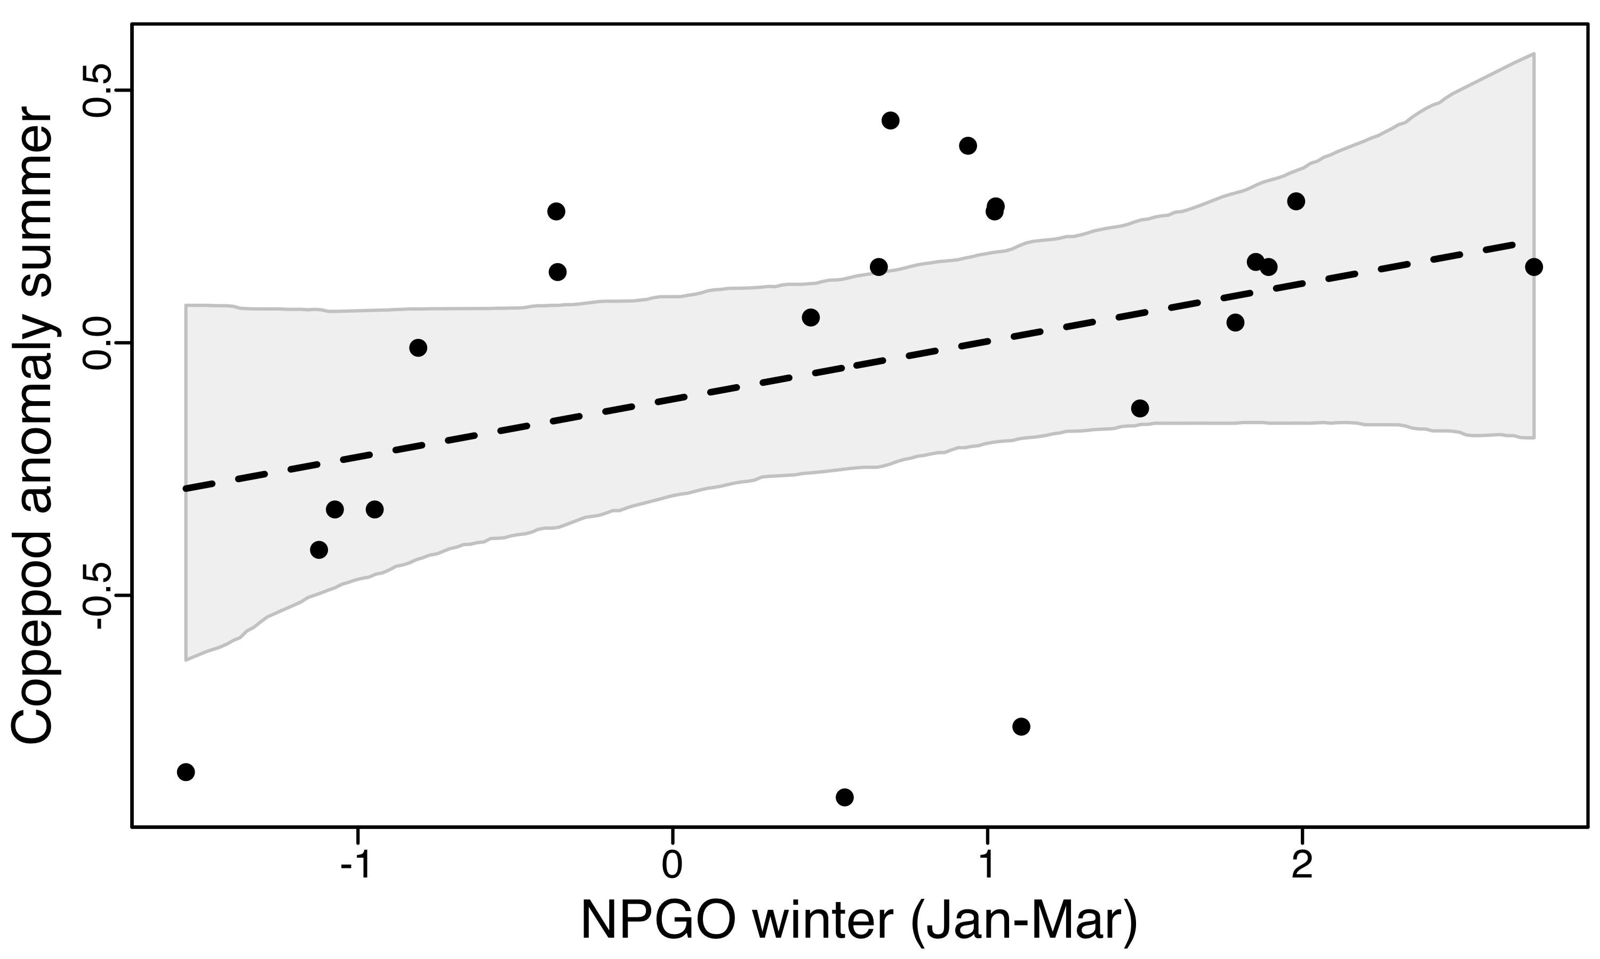

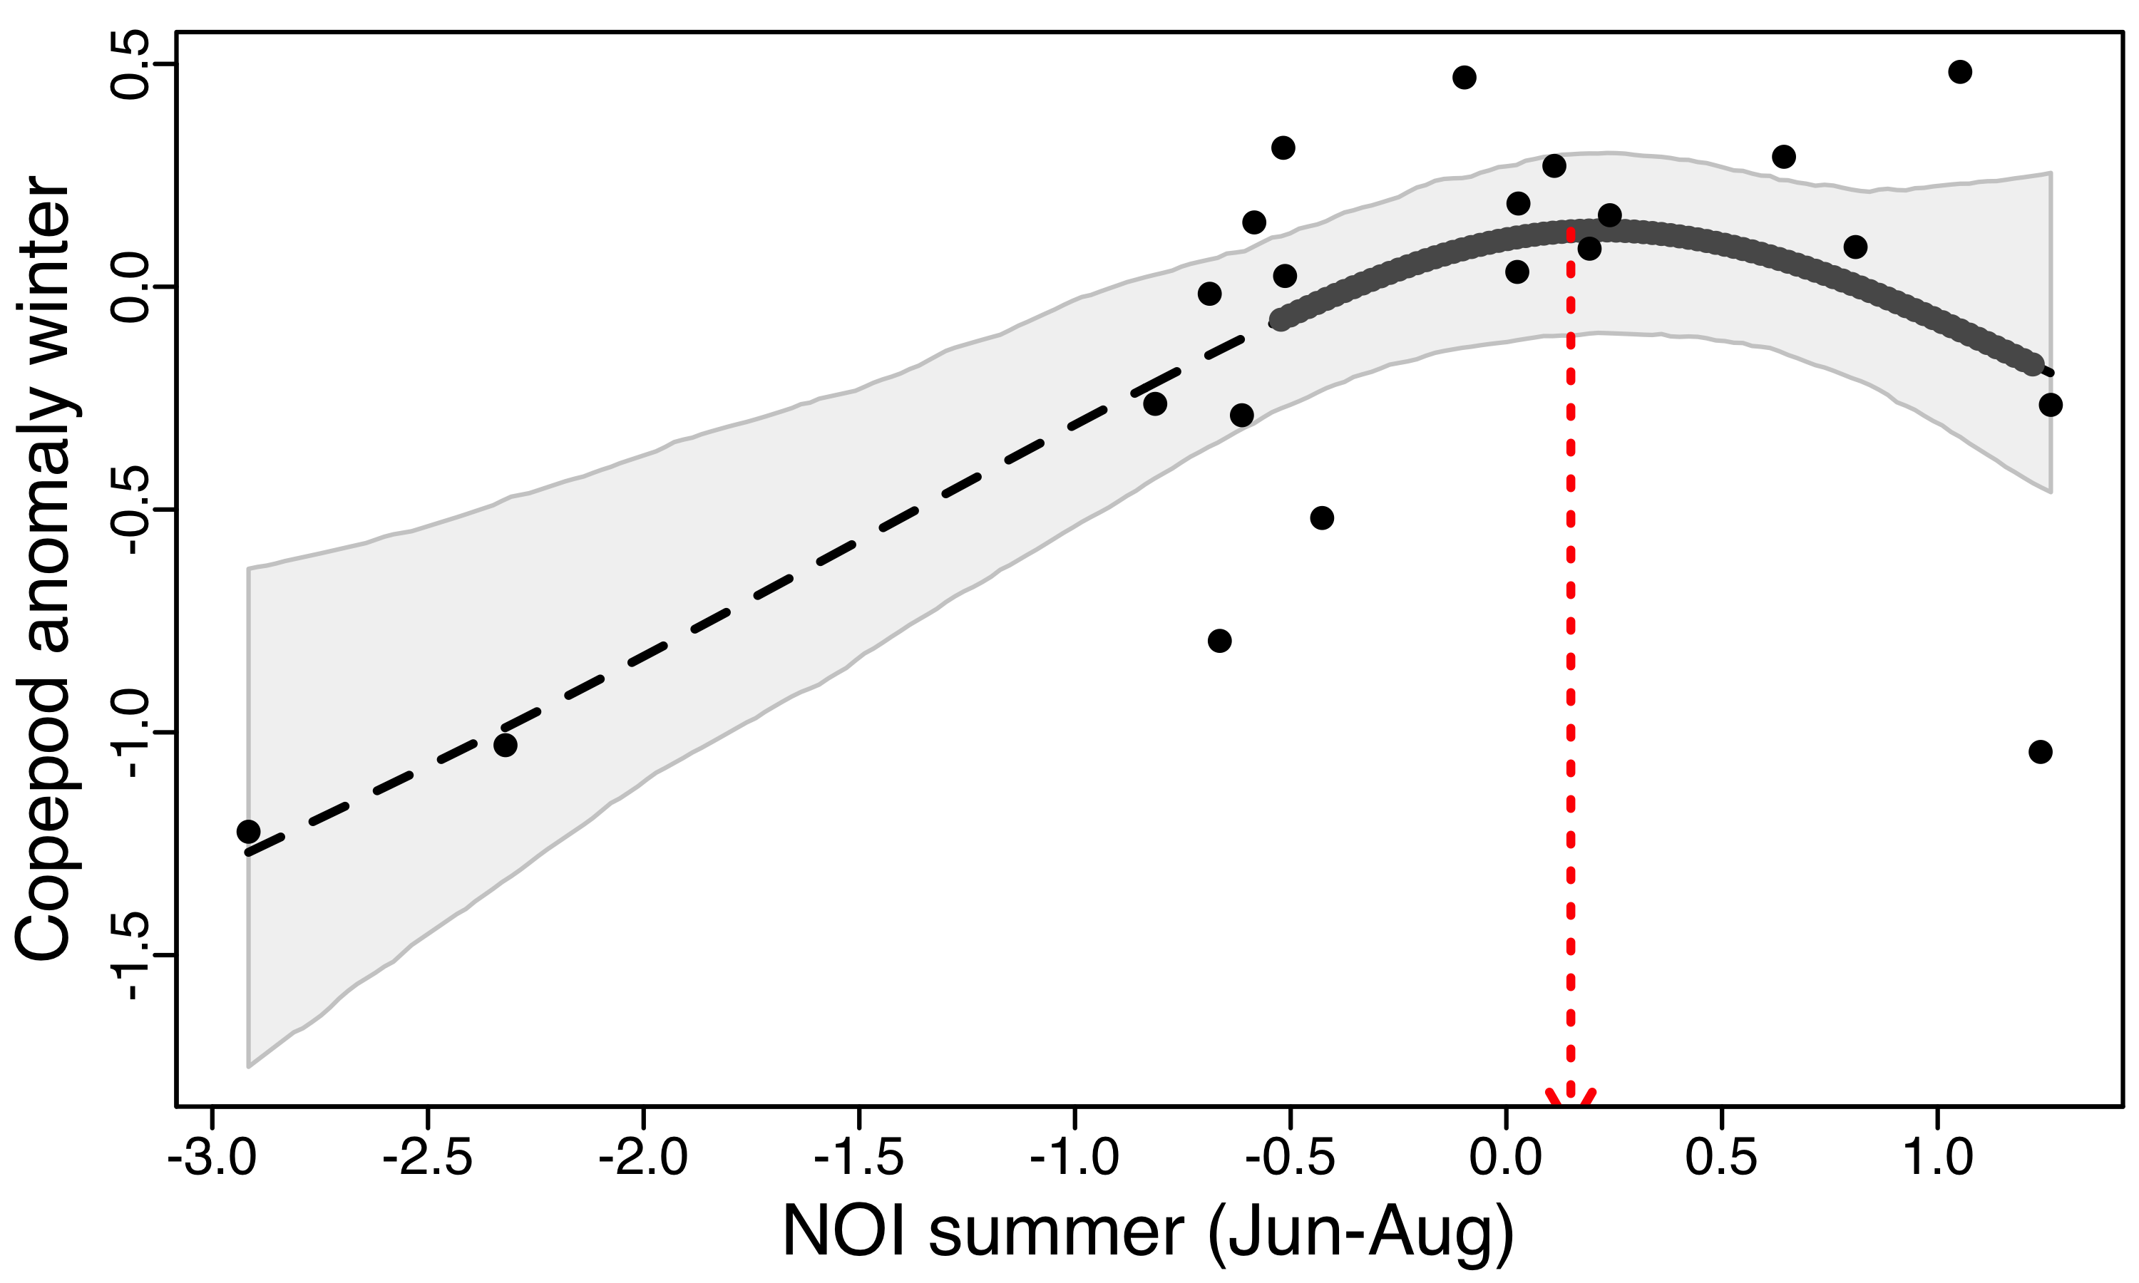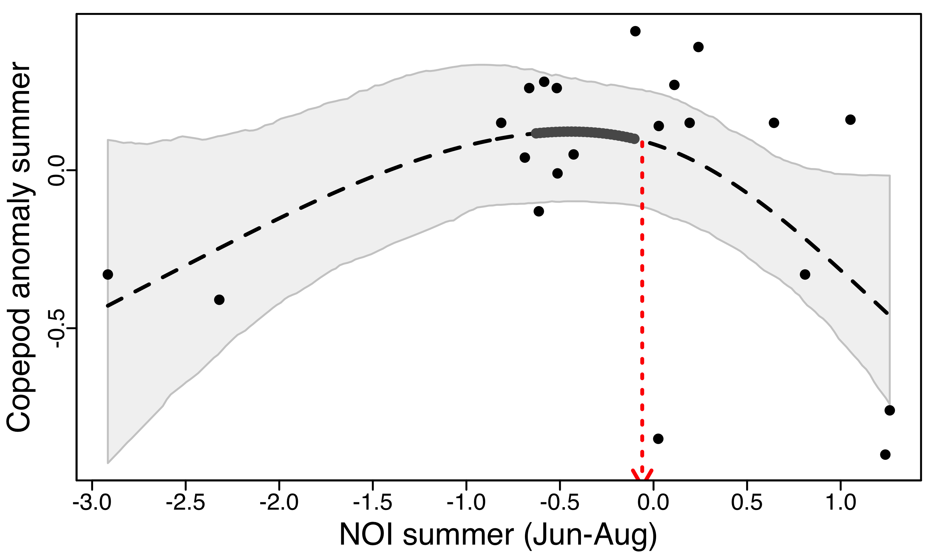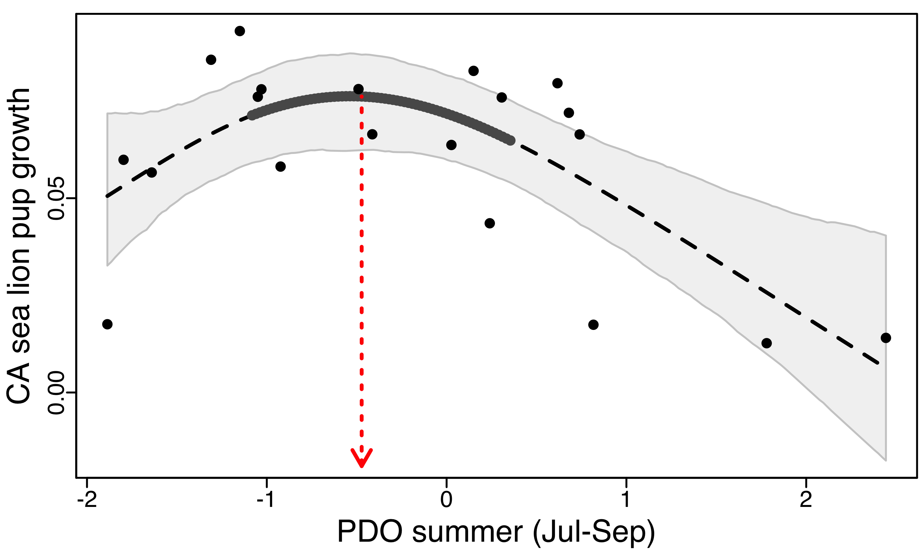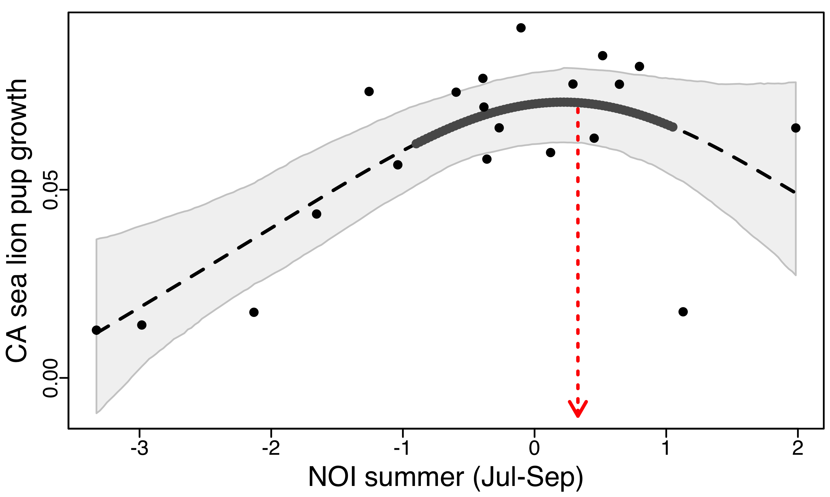Fig A4. Relationships identified as “linear” in previous analysis (using 1996-2014 data; GAM edf>2.0), but have been identified as “non-linear” in updated analysis (1996-2016 data; GAM edf>1.8). See Fig A1 caption for additional details.

Probably shouldn’t show this final figure since we don’t have a good established hypothesis…but we could go out on limb and show for some input:

Fig A5. Relationships identified as “non-linear” but need further discussion with component experts to discern specific mechanistic underpinnings of these results. See Fig A1 caption for additional details.

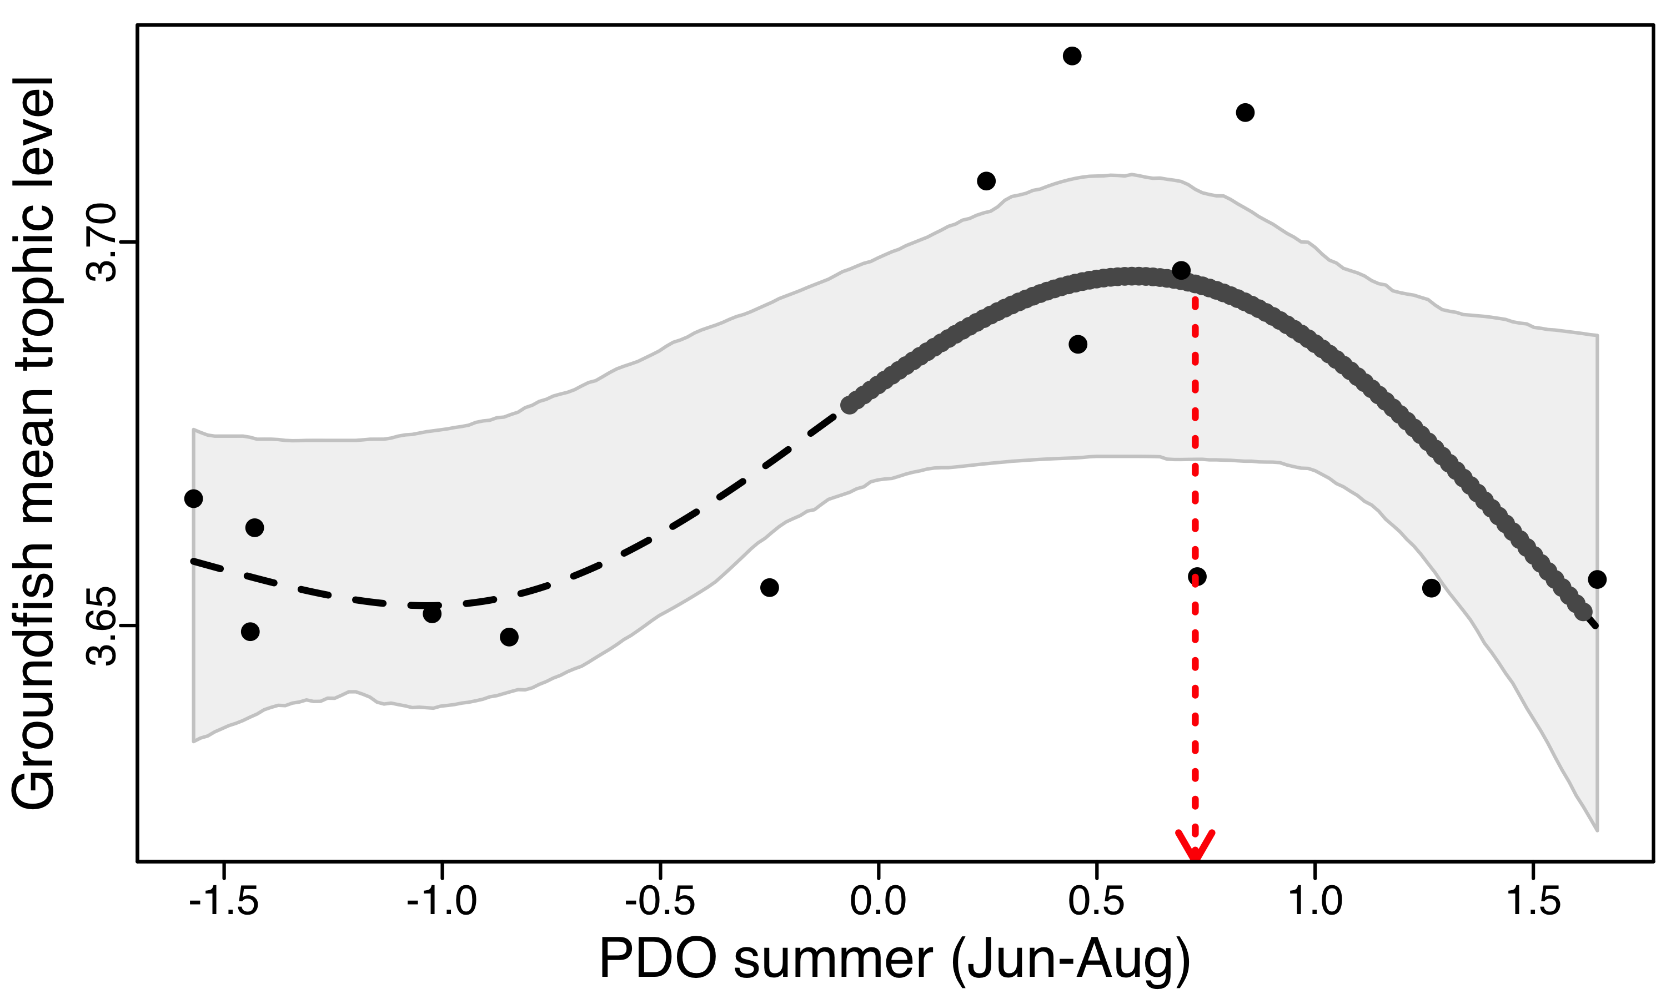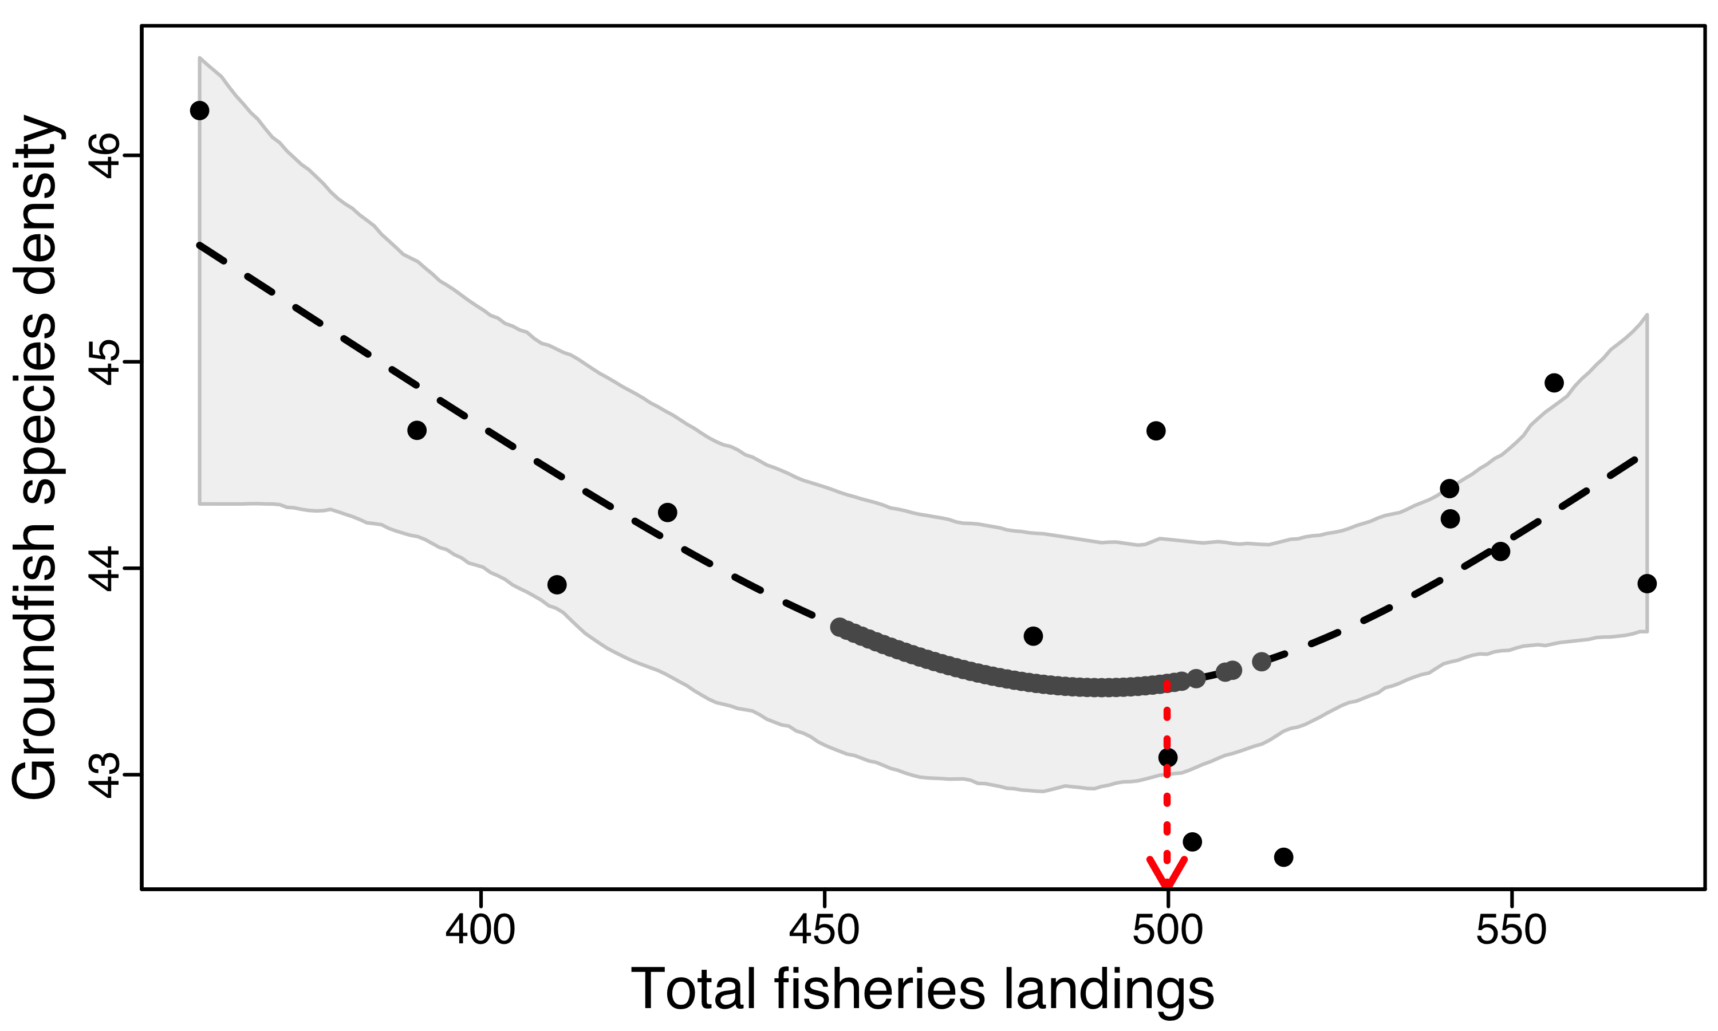

**Summary of updated reference points analysis using data from 1996 to 2016:**

Data, code and results can be found in the “CCIEA Reference Points update for SoCC Report 2018” google folder: <https://drive.google.com/open?id=1_8_ITHJzF-CzZZtZfYh2y8xNETfIik1V>

Due to differences in oceanographic index calculations (our original analysis calculated summer modes by averaging monthly values for June – August, whereas the IEA report now averages from July – September), I included both summer calculations to look for threshold relationships.

**Data used:** 1996.2016.reference.points.data.csv

**Code used:** gamThresholds_for_SoCC_Report.R

**Results:**

1. 153 response-driver relationship combinations (see output/1996/1996.all.models.summary.out.csv)
   1. 134 combinations had “linear” as best model
      1. 36 relationships were significant (p<0.05)
         1. Examples
            1. Groundfish diversity NPGO summer (Jul-Sep)
            2. 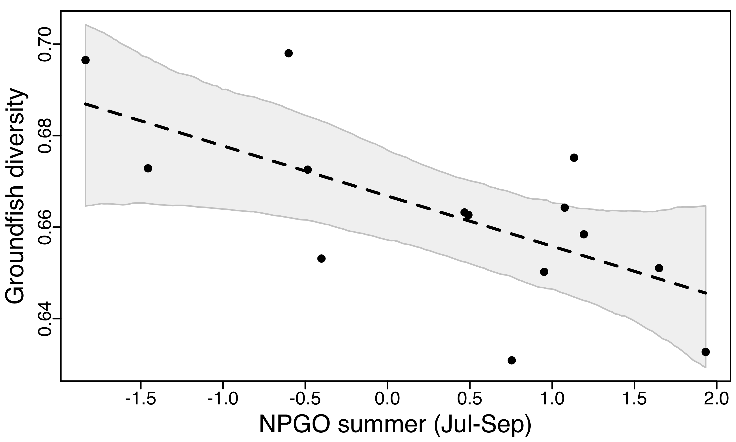Copepod anomaly winter PDO summer (Jul-Sep) – [WHOA]
   2. 15 combinations had “LMAC” as best model (p.ac<0.05, but edf < 2.0)
      1. None were significant at the p<0.05 level
         1. Examples
            1. Groundfish mean trophic level Groundfish landings
            2. 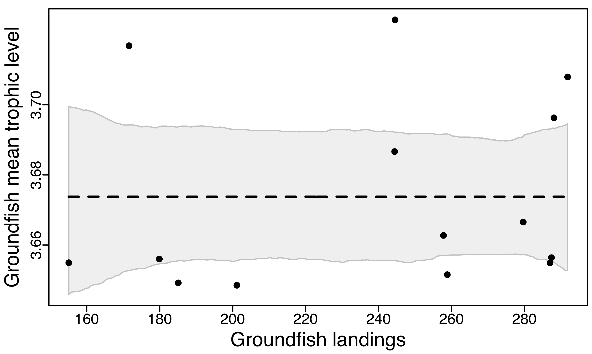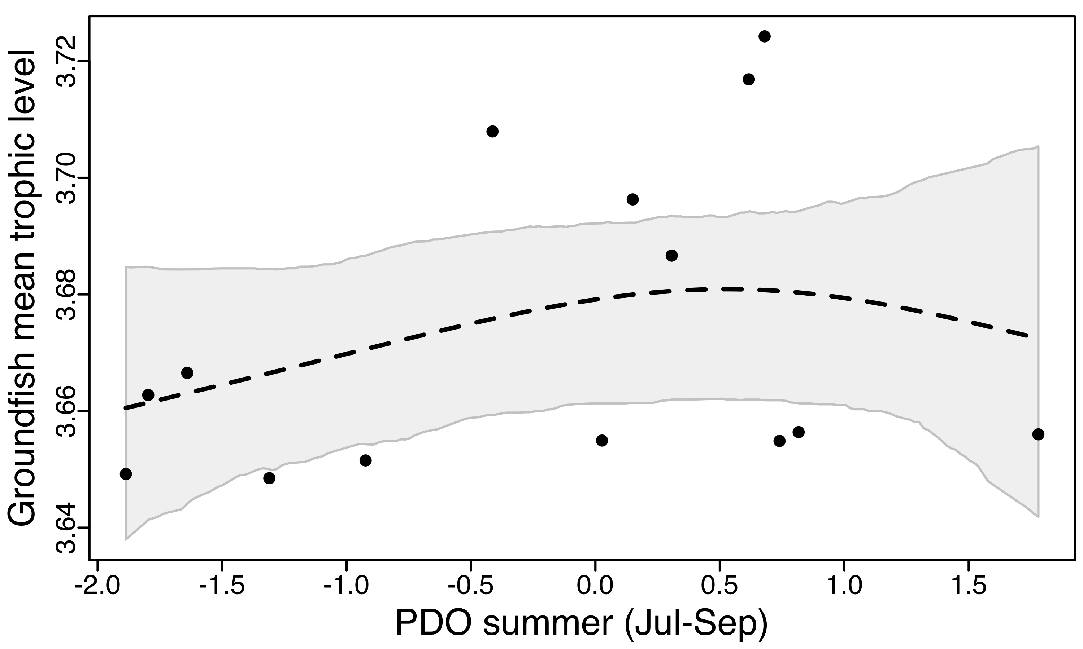Groundfish mean trophic level PDO summer (Jul-Sep)
   3. 4 combinations had “GAM” as best model
      1. Significant non-linear relationships with GAM models
         1. All four relationships
            1. CA sea lion pup growth Habitat modification
            2. CA sea lion pup production NOI summer (Jun-Aug)
            3. Groundfish mean trophic level PDO summer (Jun-Aug)
            4. 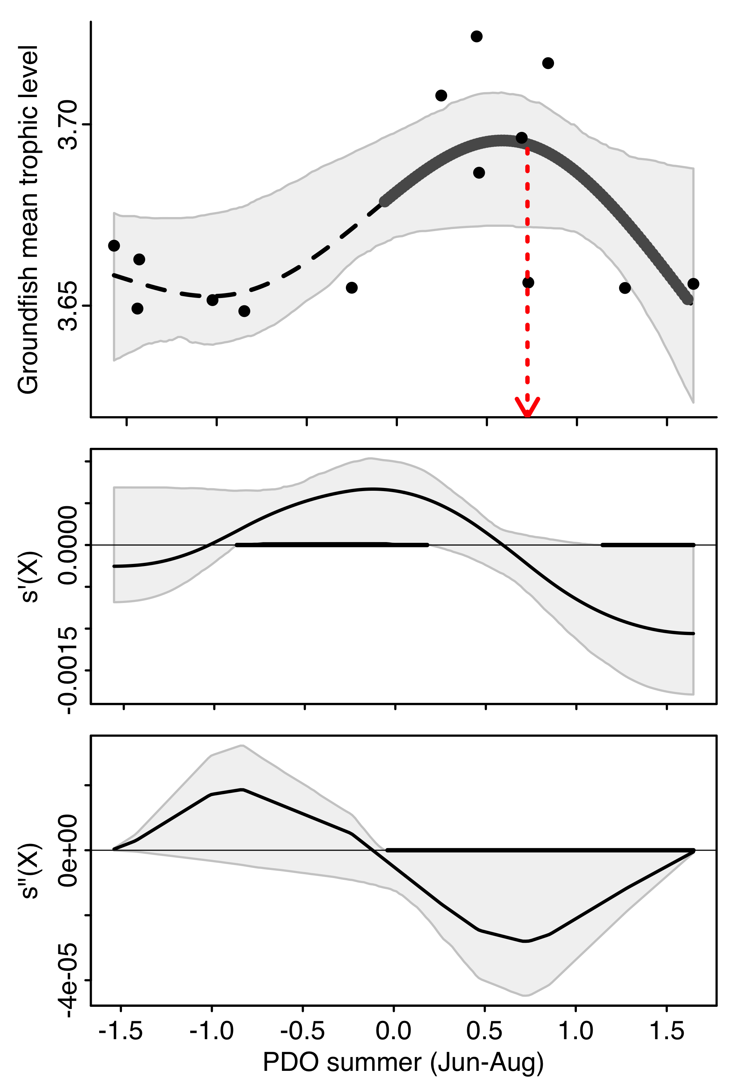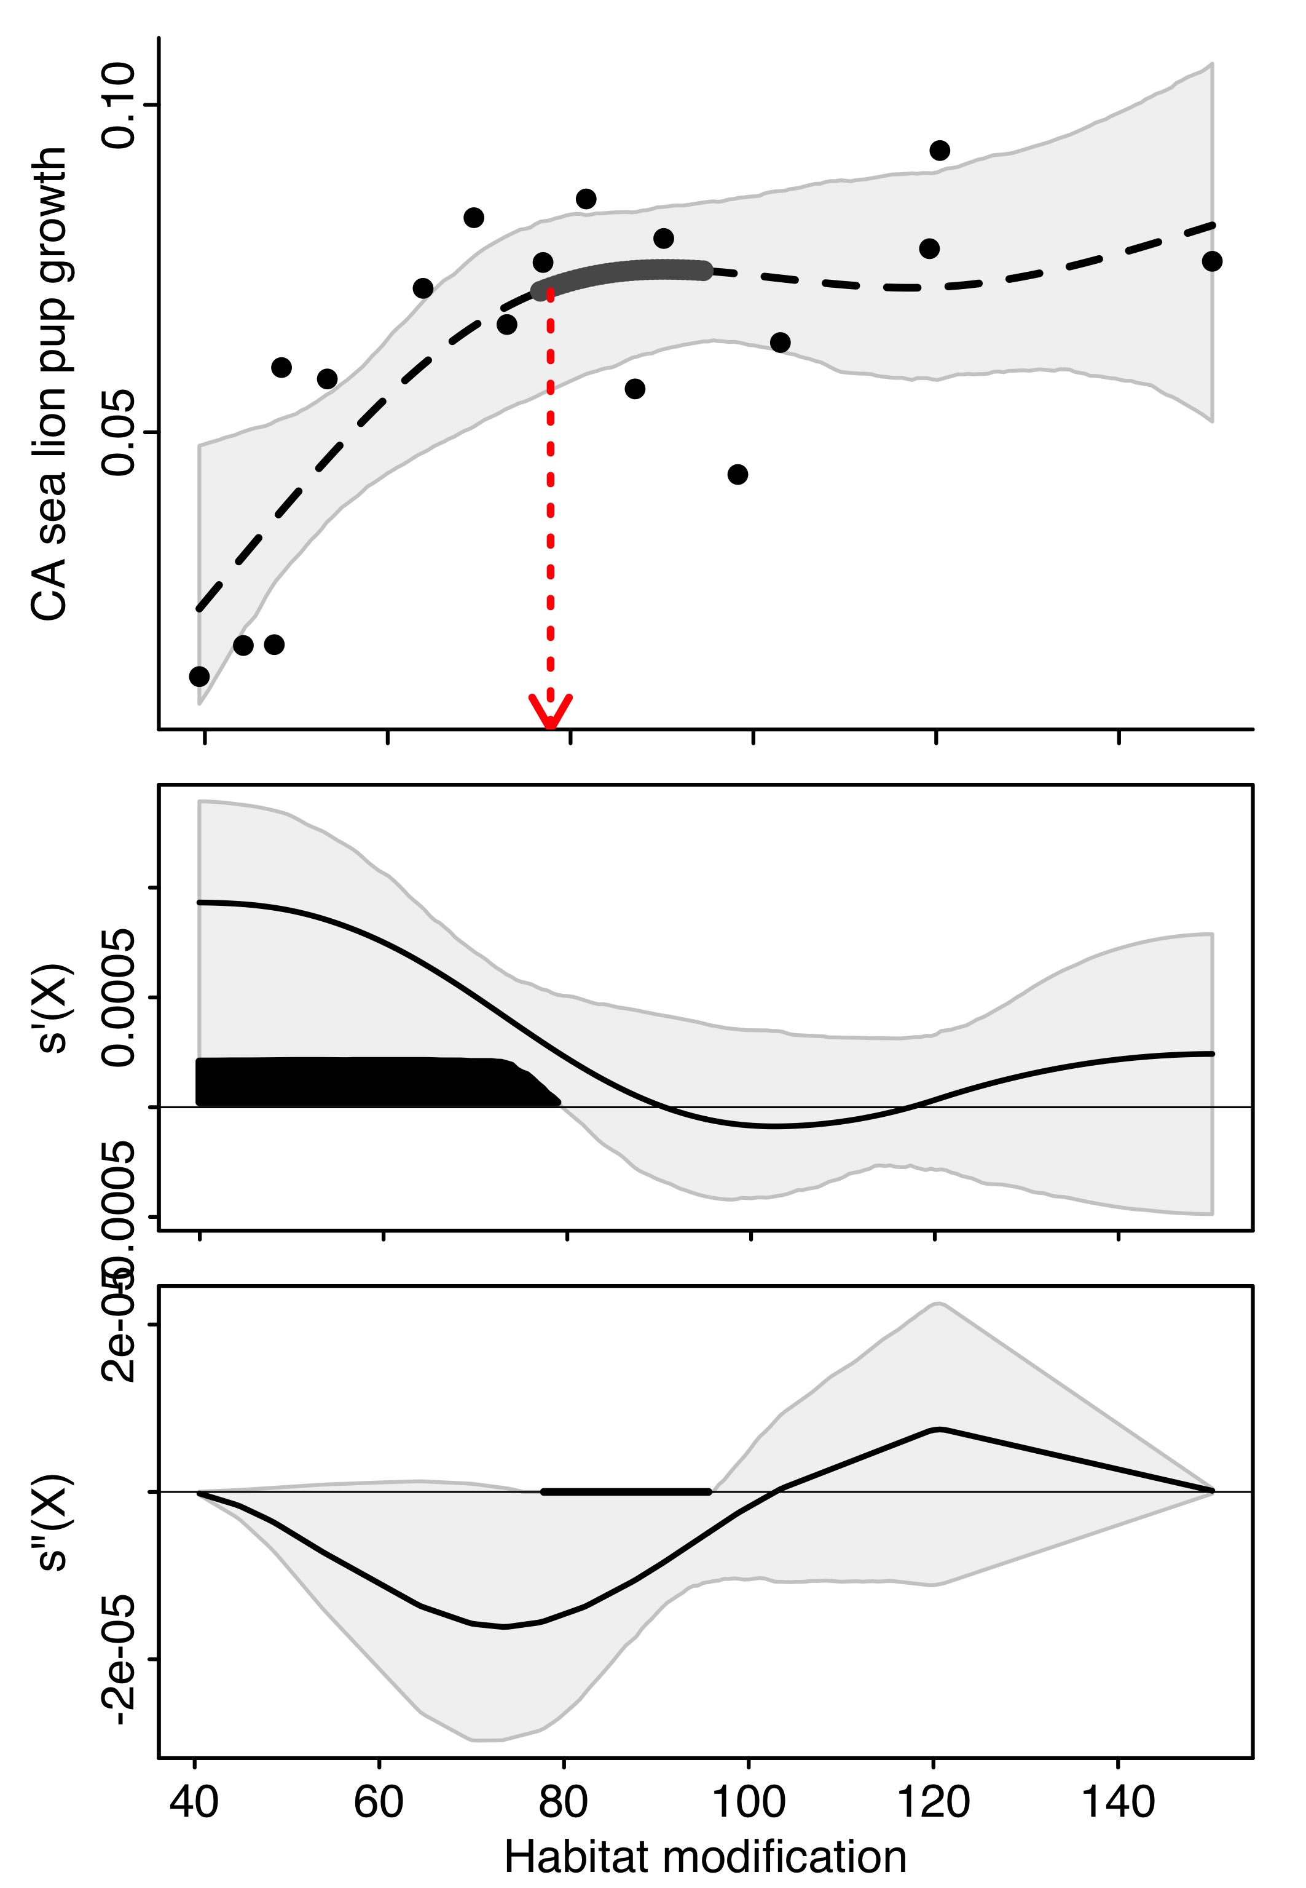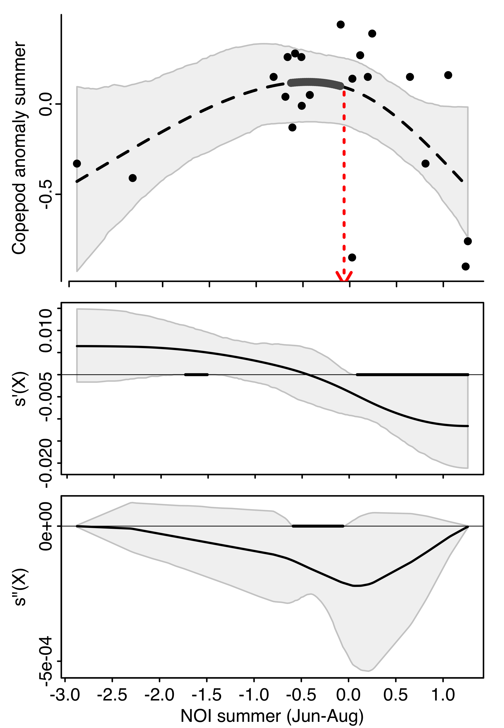Copepod anomaly summer NOI summer (Jun-Aug)
   4. 0 combinations had “GAMM” as best model
2. Every significant GAM relationship had a single significant threshold level (see: output/1996/1996.magnitude of threshold.gam.csv). In our Ecosphere paper, one significant non-linear relationship did not have a significant threshold.
3. There were 9 linear relationships that were identified to have a threshold (only seen because I had all combinations plotted, whereas in the past, I only plotted and looked for thresholds of relationships that had significant non-linearities). These look to be relationships where the edf value is just under 2.0. Some of these are repeats using both averages of summer PDO or NOI.
   1. CA sea lion pup growth NOI summer (Jul-Sep); edf=1.819761839
   2. 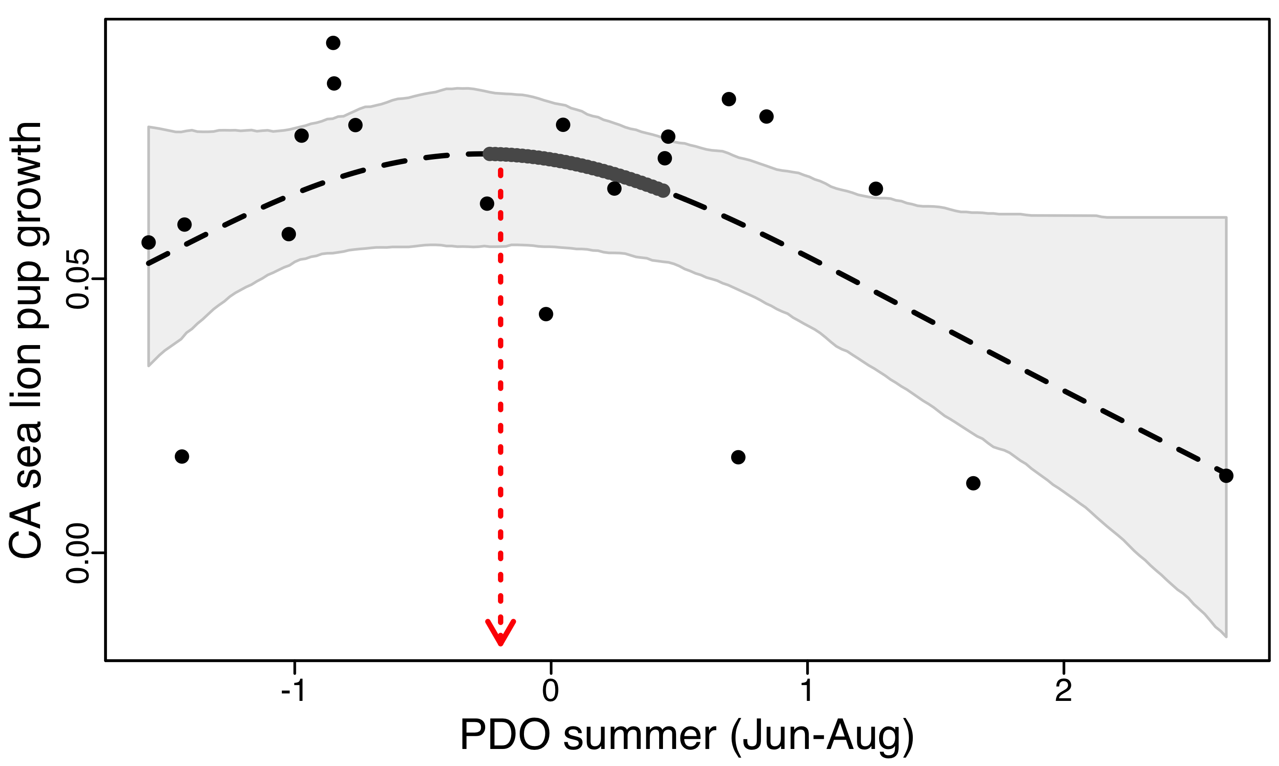CA sea lion pup growth PDO summer (Jul-Sep); edf=1.879853136
   3. CA sea lion pup growth PDO summer (Jun-Aug); edf=1.79262009
   4. Groundfish species density Total fisheries landings; edf=1.822910913
   5. Groundfish diversity NOI summer (Jul-Sep); edf=1.767529911
   6. 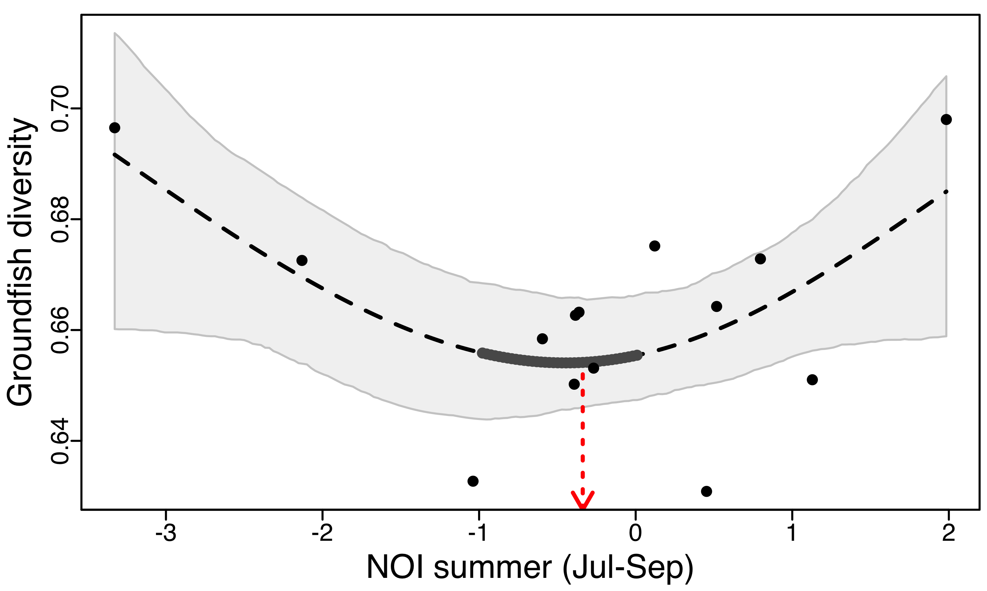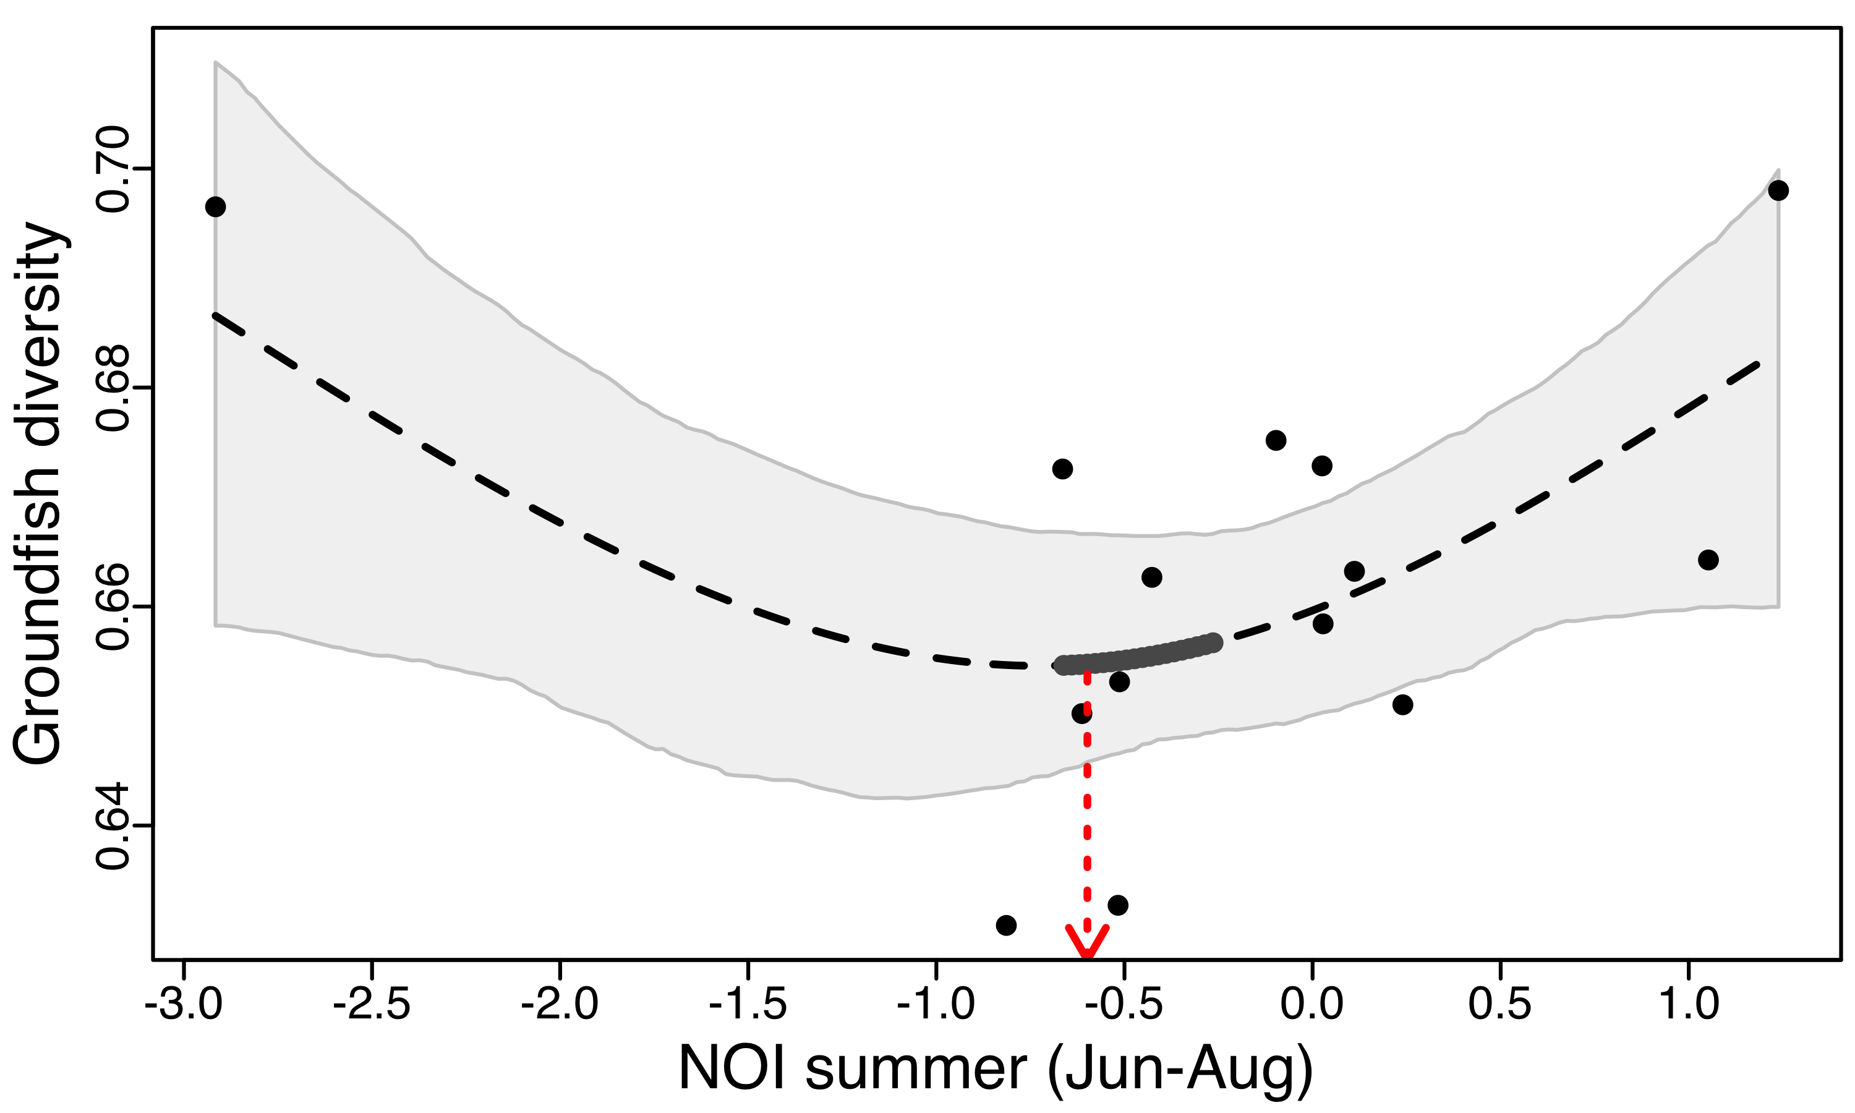Groundfish diversity NOI summer (Jun-Aug); edf=1.579440238
   7. Copepod anomaly summer NOI summer (Jul-Sep); edf=1.740491011
   8. Copepod anomaly winter NOI summer (Jul-Sep); edf=1.907036819
   9. 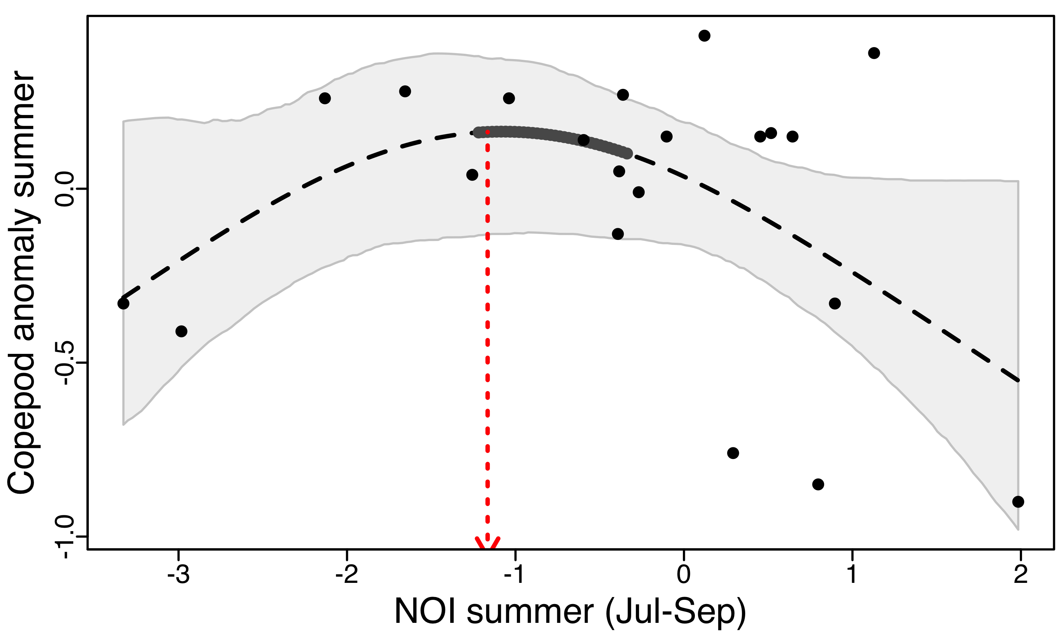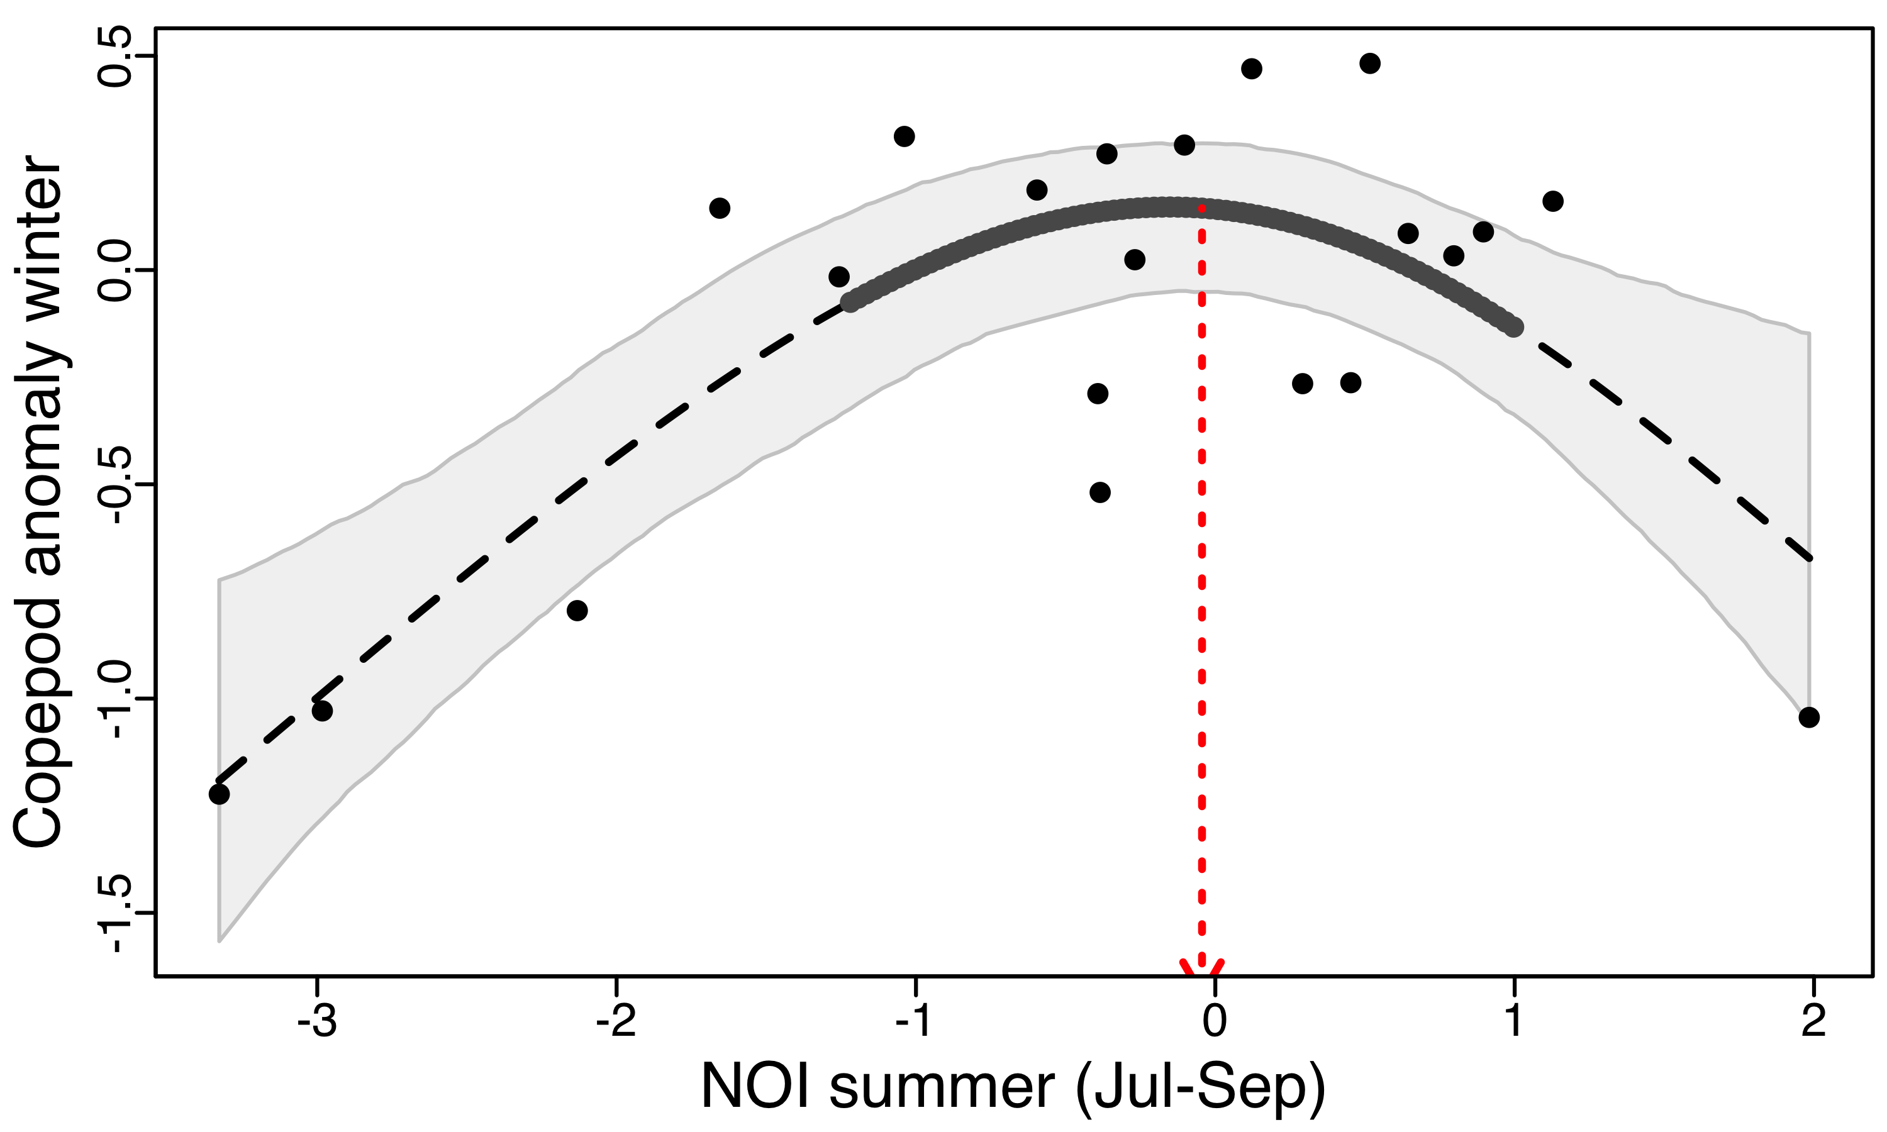Copepod anomaly winter NOI summer (Jun-Aug); edf=1.8470723

**Discussion:**

1. We had four significant “GAM” non-linear relationships in previous analysis (1996-2014 data)
   1. Previous analysis (1996-2014)
      1. Pup production NOI summer
      2. Pup production PDO summer – no significant threshold
      3. Copepod summer NPGO winter
      4. 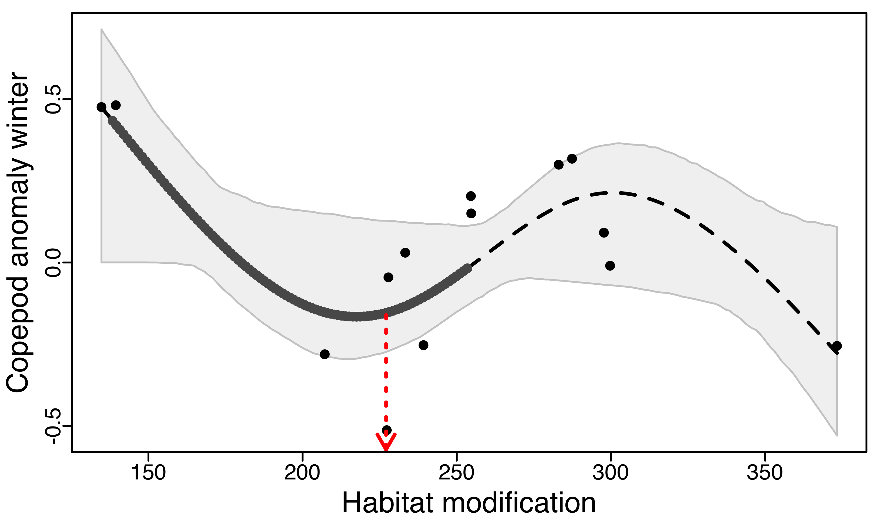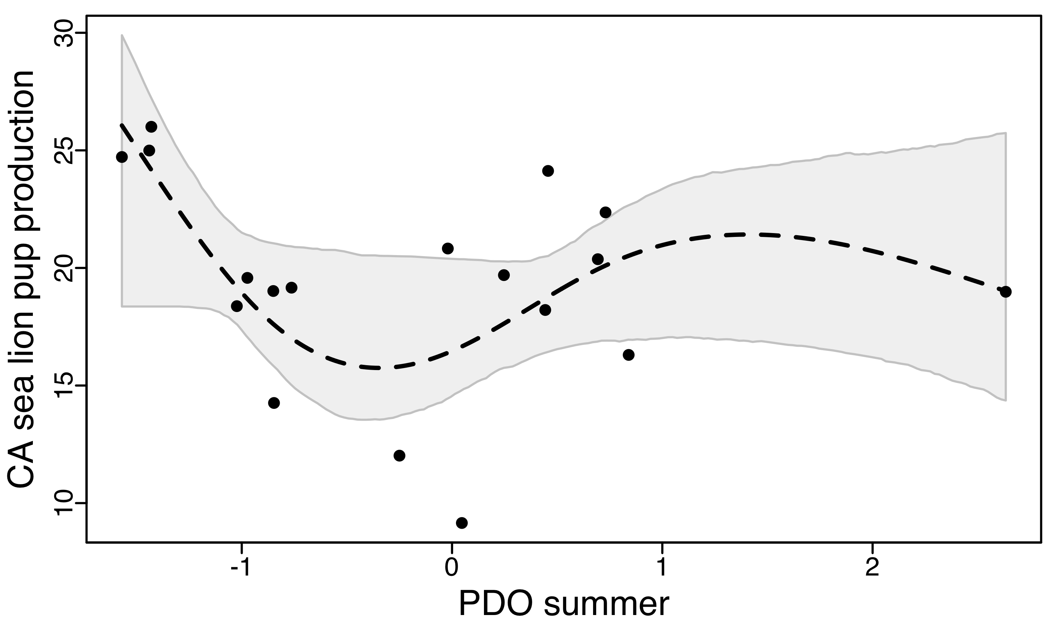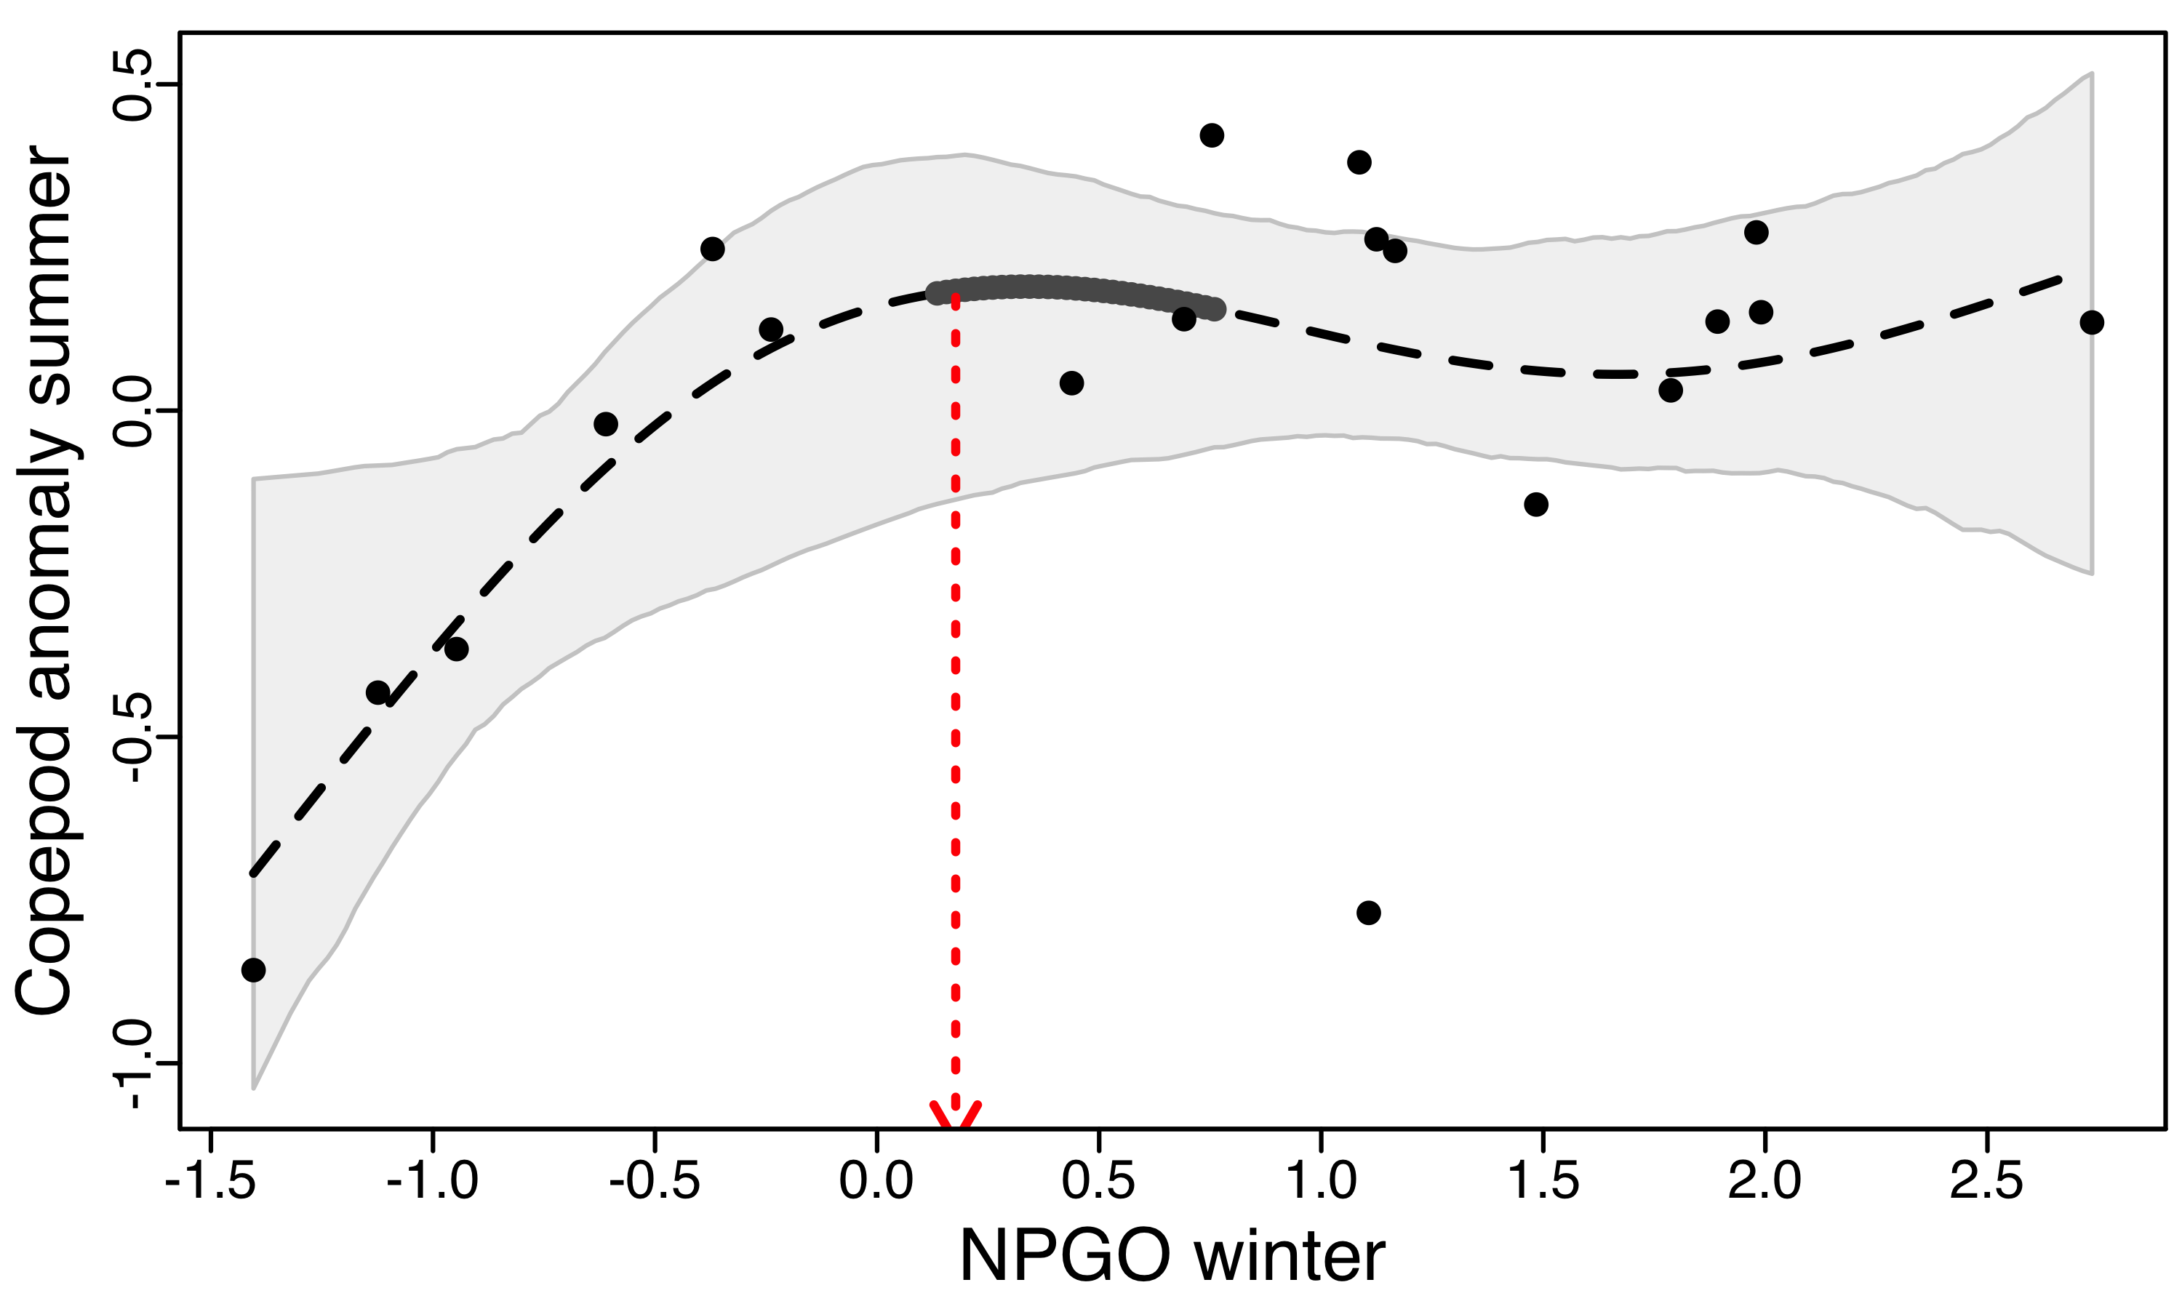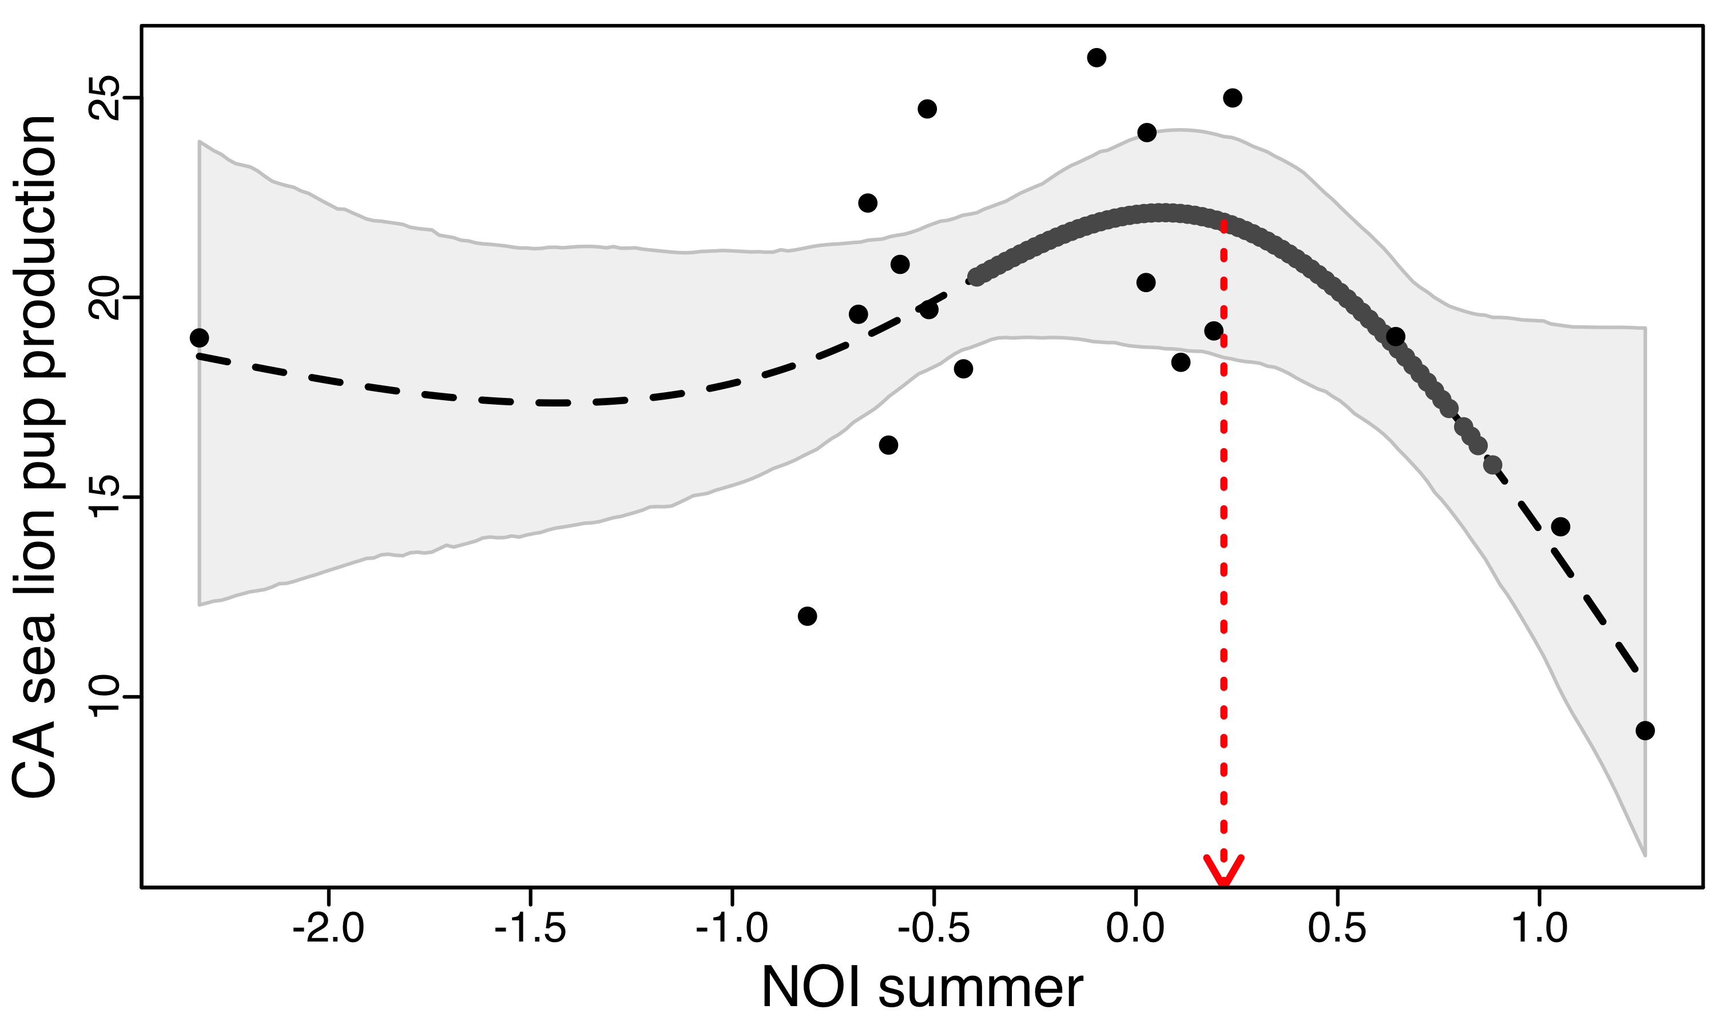Copepod summer Habitat modification
   2. Updated analysis (1996-2016), out of those initial four significant relationships from 1996-2014, we only found one (Pup production NOI summer (Jun-Aug) that remained significant:
      1. **Pup production NOI summer**
      2. Pup production PDO summer – no significant threshold
      3. Copepod summer NPGO winter
      4. 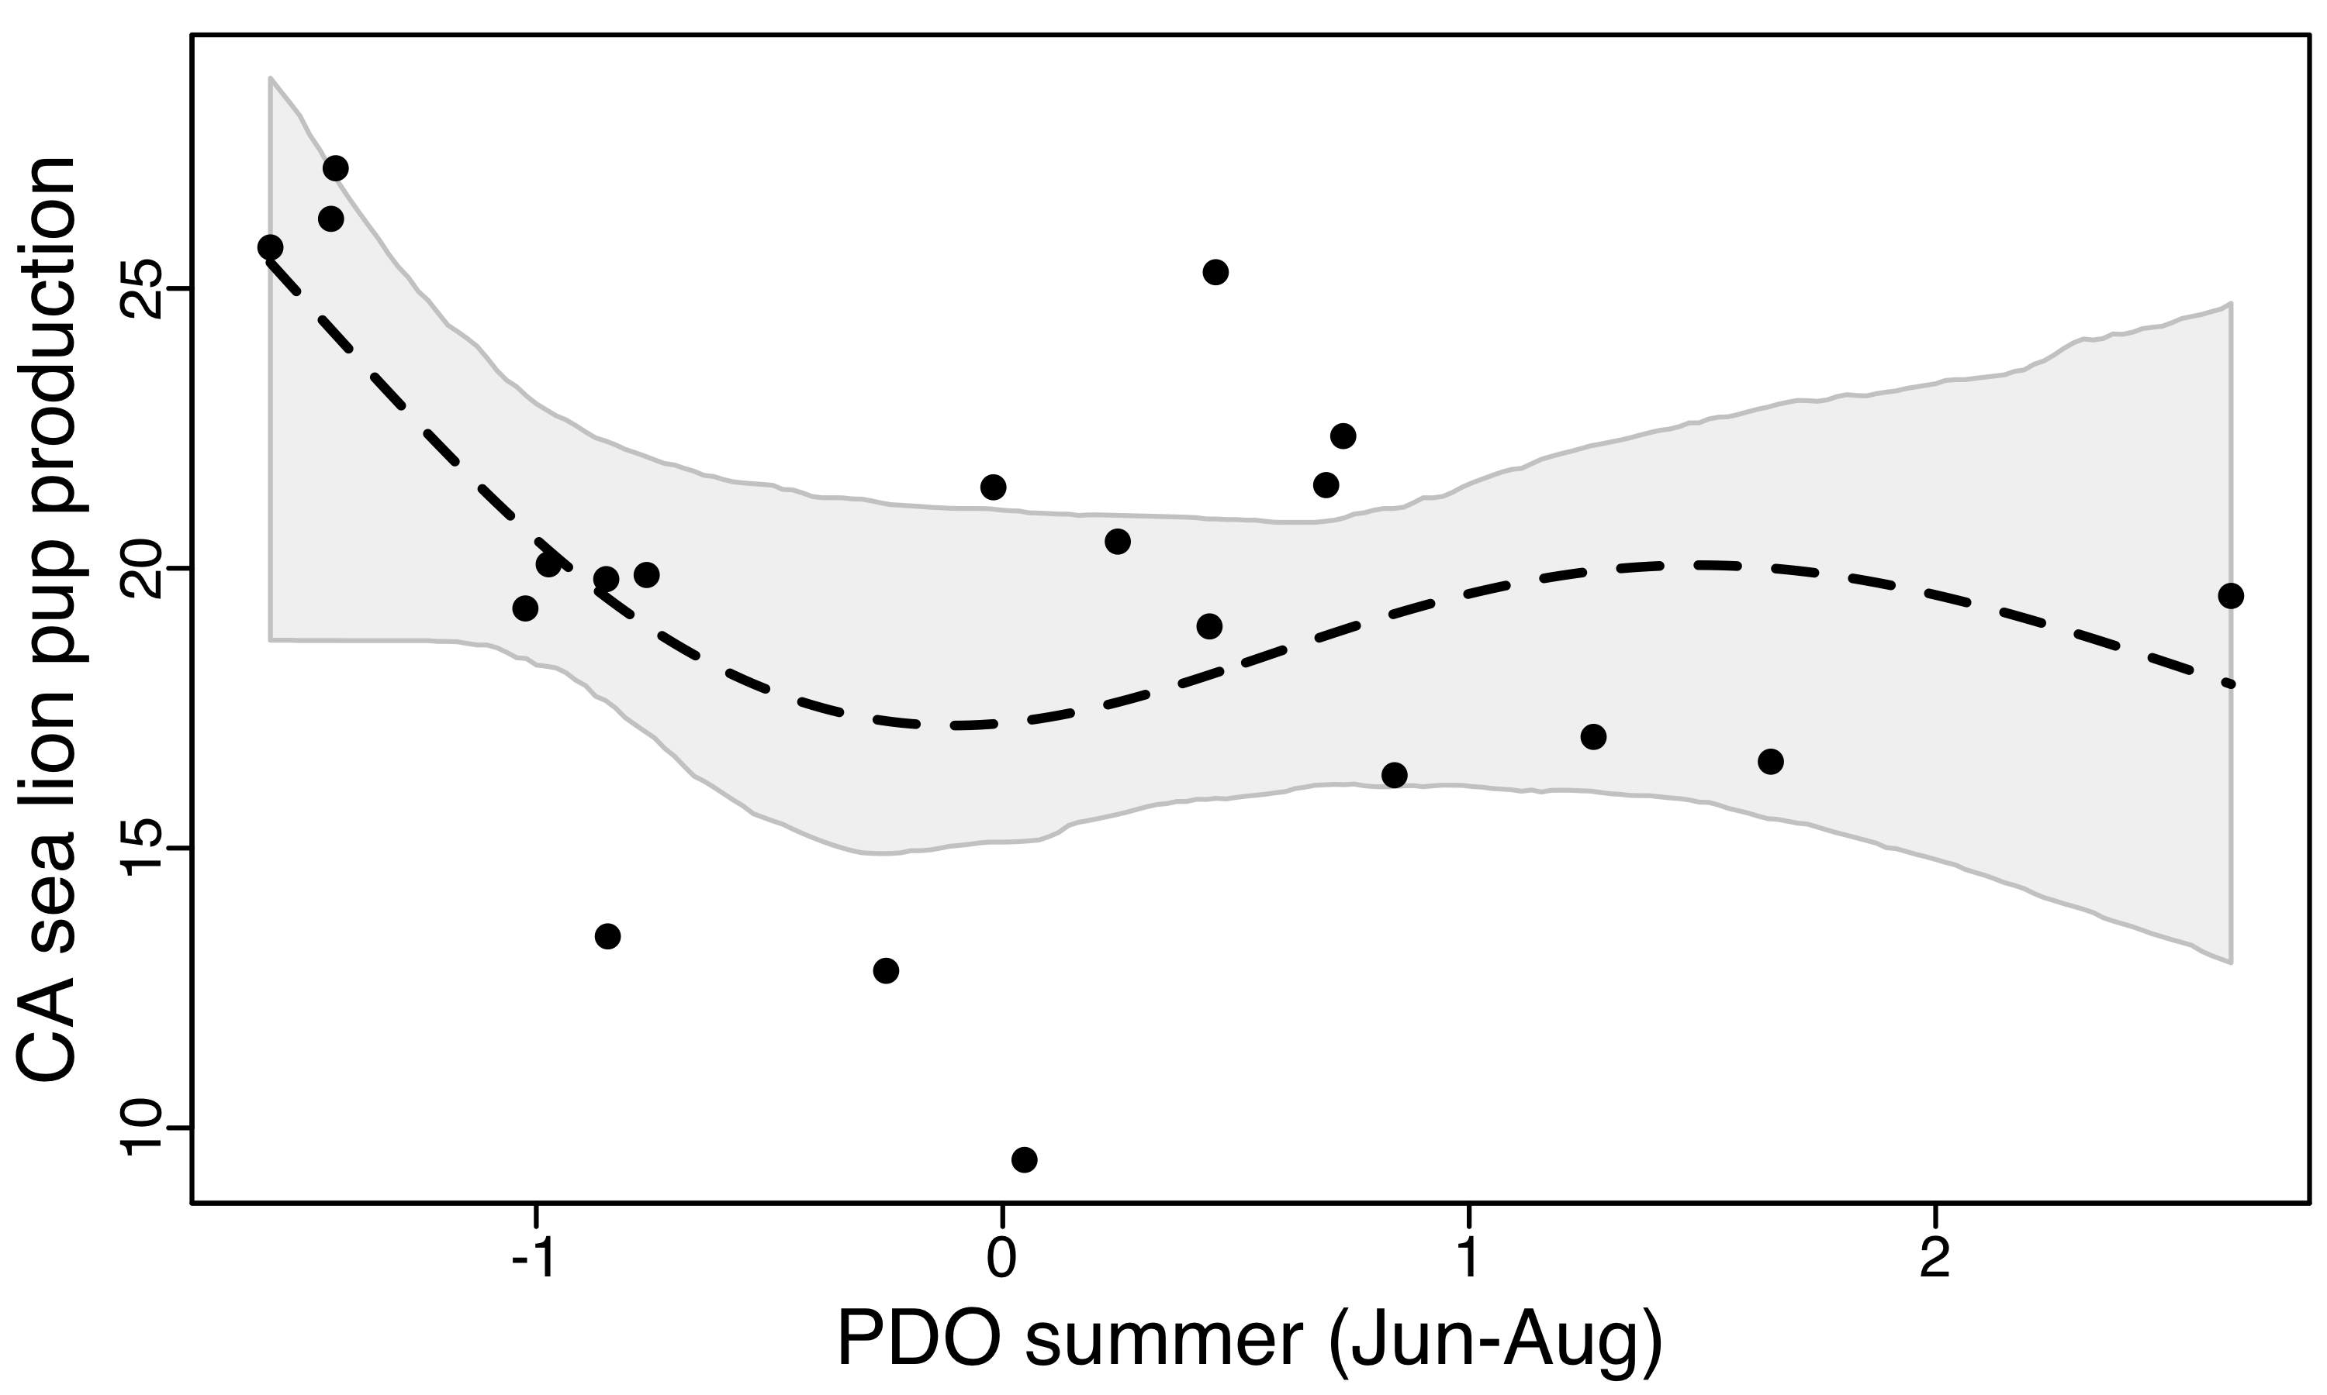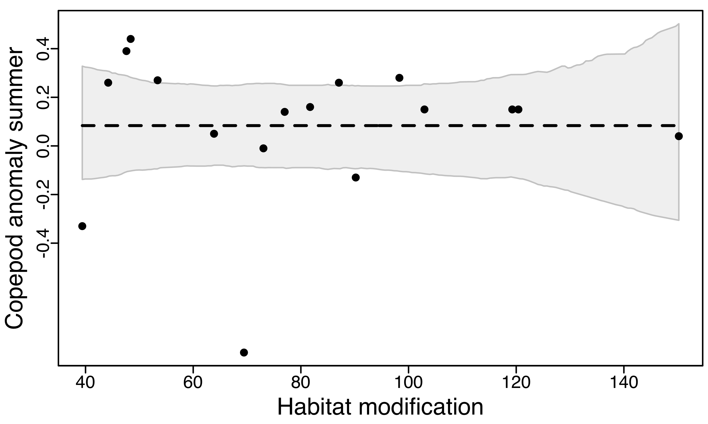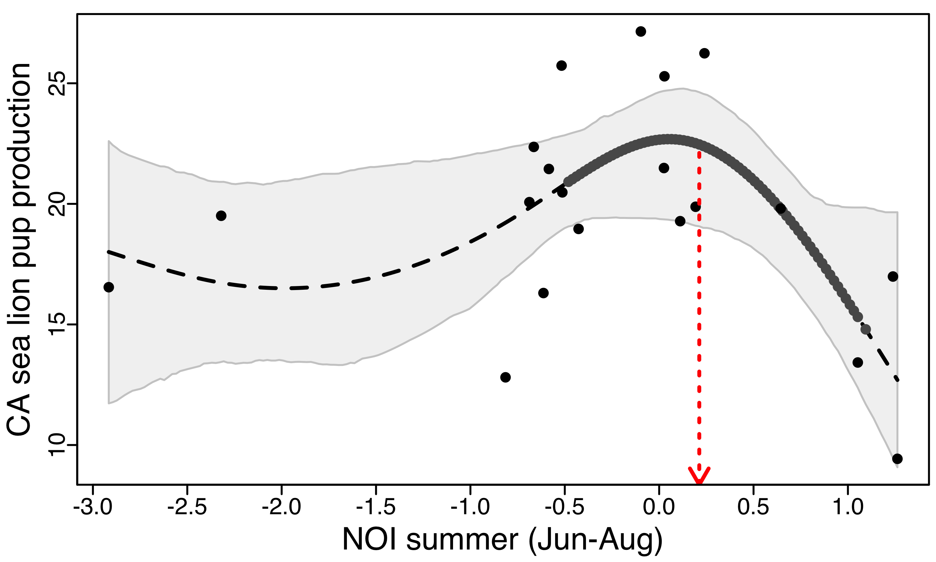Copepod summer Habitat modification (caveat: habitat modification data has changed to a weighted value based on impact level between bottom trawling distances versus fixed-gear distances – so this could account for this big difference between analyses)
2. New results from 1996-2016 analysis
   1. Four significant non-linear “GAM” relationships
      1. **CA sea lion pup production NOI summer (Jun-Aug)**
      2. CA sea lion pup growth Habitat modification
      3. Groundfish mean trophic level PDO summer (Jun-Aug)
      4. Copepod anomaly summer NOI summer (Jun-Aug)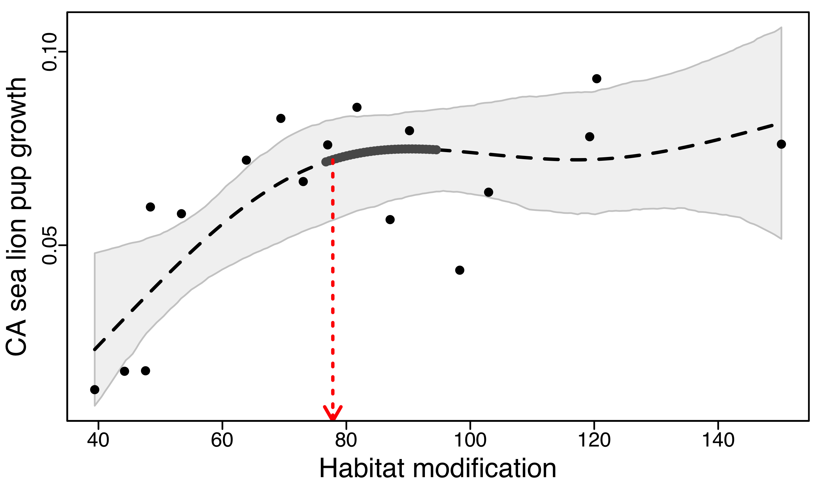
   2. Other non-significant non-linear relationships that are just below our edf>=2.0 threshold for significance.
3. The months used to calculate the seasonal modes of each oceanographic index is important in these threshold analyses!
   1. None of the relationships using July-Sept as the summer months were found to be significant.
   2. Is there a set of months that are good for broad-scale descriptions of each season?
   3. Are there a set of months that better capture the driving environmental forces for each species (i.e. could this be species- or taxa-specific?)?
   4. We should really incorporate lags and determine which season and/or lagged year should be used to look for these thresholds! This could be really fun! Chat with copepod and sea lion pup folks and get their intuition.
4. Sea lions and NOI Summer
   1. 2015 and 2016 had remarkably similar pup counts despite dramatically different NOI conditions. The relationship remains nonlinear and the threshold is in approximately the same place.

Sea%20lion%20pups%20plots.pdf

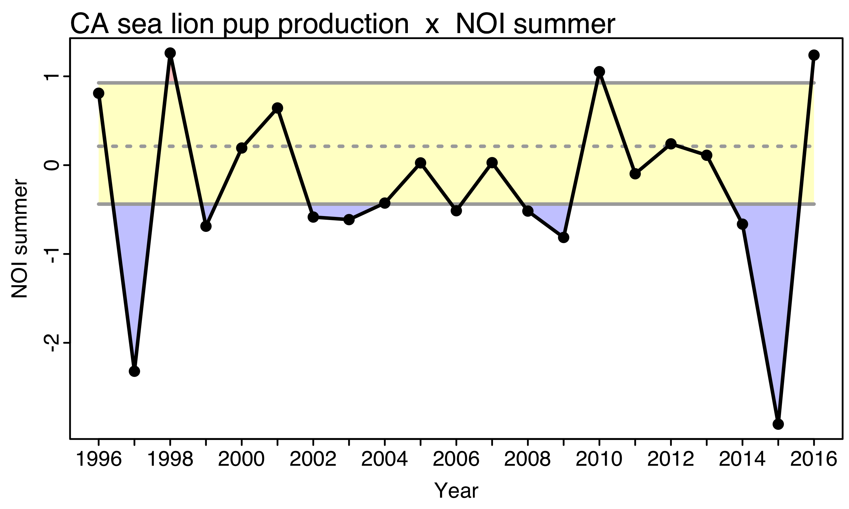

1. Note that there is now a significant nonlinear relationship between NOI summer and copepod summer.

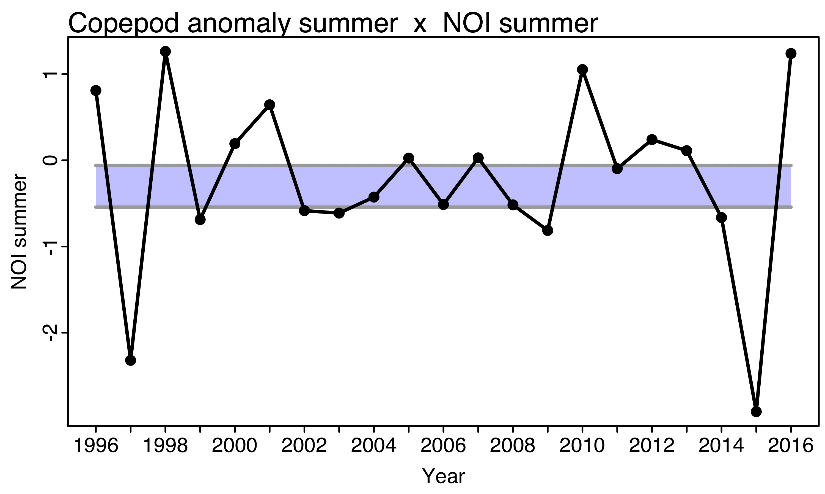

1. Northern copepod summer and NPGO Winter
   1. 2016 was an anomalously low year for copepods, with modestly positive NPGO values, much like 1998. This caused the curviness of the relationship (edf) to diminish substantially. Now the most parsimonious relationship between copepods and NPGO is linear.

Copepods%20plots.pdf